Internal verification of assessment decisions – BTEC Higher Nationals (RQF)

INTERNAL VERIFICATION – ASSESSMENT DECISIONS (Single Student)
Programme Title:
Unit Number and Title:
Assessor Name: |  |  |  | Internal Verifier Name:
Assignment title:
Name of student | Submission Type  (First, Resubmission, Retake) | Grade the Assessor has awarded. | Assessment Decision Accurate (Y/N)  (Resubmission and retake must be capped at a Pass) | List the learning outcomes and grading criteria where inaccurate decisions have been made |  | State why the assessment decision is inaccurate.  *If an inaccurate decision is recorded the Internal Verifier must recommend actions detailing the issues to be addressed. The Assessor and the Internal Verifier must then confirm that the action has been undertaken before assessment decisions are issued to the student.
INTERNAL VERIFIER CHECKLIST |  |  |  |  |  |  | Y/N
Has the student and the Assessor confirmed the authenticity of the evidence?
Is there evidence of collusion or plagiarism? The work submitted for assessment has been carried out without assistance other than that which is acceptable according to the rules of the specification. The evidence submitted for this assignment is student’s own. The student has clearly referenced any sources and any artificial intelligence (AI) tools used in the work.
Is the assessor feedback to the student appropriate and constructive to each student? Provide comments below.
- Points out strengths and areas for improvement.
- Linked to relevant learning outcomes and assessment criteria.
- Clear as to why the student did not achieve higher grades.
- Identify opportunities for improved performance in future assignments.
GENERAL COMMENTS
Any actions required must be reviewed across the whole cohort.
Action Required |  |  |  |  | Target Date for Completion |  |  | Date Action Completed
I confirm that the assessment decisions are accurate, there is no evidence of assessment malpractice and any action points have been addressed and completed in respect of the whole cohort. I declare the work submitted for assessment has been carried out without assistance other than that which is acceptable according to the rules of the specification. The evidence submitted for this assignment is student’s own. The student has clearly referenced any sources and any artificial intelligence (AI) tools used in the work.
Internal Verifier signature |  |  |  |  | Date
Assessor signature |  |  |  |  | Date

Higher Nationals - Summative Assignment Feedback Form

Student Name/ID | MN. Sihanas / 1030371
Unit Title | INTERNET OF THINGS
Assignment Number | Assignment 01 | Assessor
Submission Date |  | Date Received 1st submission
Re-submission Date |  | Date Received 2nd submission
Assessor Feedback:

I certify that to the best of my knowledge the evidence submitted for this assignment is the student’s own. The student has clearly referenced any sources and any artificial intelligence (AI) tools used in the work. I have not solely used AI to grade the student’s work.

Grade: | Assessor Signature: |  | Date:
Resubmission Feedback:

Grade: | Assessor Signature: |  | Date:
Internal Verifier’s Comments:
Signature & Date:

* Please note that grade decisions are provisional. They are only confirmed once internal and external moderation has taken place and grades decisions have been agreed at the assessment board.
Pearson Education 2016
Higher Education Qualifications
Internal Verification of Assignment Brief

Student Assessment Submission and Declaration
When submitting evidence for assessment, each student must sign a declaration confirming that the work is their own.
Student name:  MN. Sihanas / 1030371 |  | Assessor name: Eng. N.T.M. Sajith
Issue date:  18.6.2025 | Submission date:  19.9.2025 |  | Submitted on:  19.9.2025
Programme:
Pearson BTEC HND in Computing
Unit: Unit 45 - Internet of Things
Assignment number and title: Design an IoT model/system to solve a real-world problem

Plagiarism
Plagiarism is a particular form of cheating. Plagiarism must be avoided at all costs and students who break the rules, however innocently, may be penalised. It is your responsibility to ensure that you understand correct referencing practices. As a university level student, you are expected to use appropriate references throughout and keep carefully detailed notes of all your sources of materials for material you have used in your work, including any material downloaded from the Internet. Please consult the relevant unit lecturer or your course tutor if you need any further advice.
Student Declaration
Student declaration
I certify that the assignment submission is entirely my own work and I fully understand the consequences of plagiarism. I declare that the work submitted for assessment has been carried out without assistance other than that which is acceptable according to the rules of the specification. I certify I have clearly referenced any sources and any artificial intelligence (AI) tools used in the work. I understand that making a false declaration is a form of malpractice.

Student signature: 1030371@bcas.ac Date: 18.9.2025

General Guidelines

- A Cover page or title page – You should always attach a title page to your assignment. Use previous page as your cover sheet and make sure all the details are accurately filled.
- Attach this brief as the first section of your assignment.
- All the assignments should be prepared using a word processing software.
- All the assignments should be printed on A4 sized papers. Use single side printing.
- Allow 1” for top, bottom, right margins and 1.25” for the left margin of each page.

Word Processing Rules

- The font size should be 12 poin, and should be in the style of Time New Roman.
- Use 1.5 line spacing. Left justify all paragraphs.
- Ensure that all the headings are consistent in terms of the font size and font style.
- Use footer function in the word processor to insert Your Name, Subject, Assignment No, and Page Number on each page. This is useful if individual sheets become detached for any reason.
- Use word processing application spell check and grammar check function to help editing your assignment.

Important Points

- It is strictly prohibited to use text boxes to add texts in the assignments, except for the compulsory information. eg: Figures, tables of comparison etc. Adding text boxes in the body except for the before mentioned compulsory information will result in rejection of your work.
- Avoid using page borders in your assignment body.
- Carefully check the hand in date and the instructions given in the assignment. Late submissions will not be accepted.
- Ensure that you give yourself enough time to complete the assignment by the due date.
- Excuses of any nature will not be accepted for failure to hand in the work on time.
- You must take responsibility for managing your own time effectively.
- If you are unable to hand in your assignment on time and have valid reasons such as illness, you may apply (in writing) for an extension.
- Failure to achieve at least PASS criteria will result in a REFERRAL grade.
- Non-submission of work without valid reasons will lead to an automatic RE FERRAL. You will then be asked to complete an alternative assignment.
- If you use other people’s work or ideas in your assignment, reference them properly using HARVARD referencing system to avoid plagiarism. You have to provide both in-text citation and a reference list.
- If you are proven to be guilty of plagiarism or any academic misconduct, your grade could be reduced to A REFERRAL or at worst you could be expelled from the course.
- Every Assignment should have an Introduction and Conclusion
- Header – include the Module name on the Right-hand side.
- Footer - include the Page number on the Right-hand side.
- All sections should have continuity and pages should be clearly labelled.
- Bibliography/Reference – Harvard referencing system Cite them right.pdf
Presentation:
- The submission is in the form of a 10-15-minute Microsoft PowerPoint style presentation. The presentation slides for the findings should be submitted with speaker notes, an individual written report, and references.

Unit 45: Internet of Things
Assignment Brief
Programme Title | Pearson BTEC HND in Computing
Student Name/ID Number | MN. Sihanas / 1030371
Unit Number and Title | Unit 45: Internet of Thing
Academic Year | 2025
Unit Tutor | Eng. N.T.M. Sajith
Assignment Title | Design an IoT model/system to solve a real-world problem
Issue Date | 18.06.2025
Submission Date | 19.09.2025
Submission Format
The submission should be in the form of an individual report written in a concise, formal business style using single spacing and font size 12. You are required to make use of headings, paragraphs and subsections as appropriate, and all work must be supported with research and referenced using Harvard referencing system. Please also provide an end list of references using the Harvard referencing system.
The recommended word count is 6,000 words for the report excluding annexures, although you will not be penalised for exceeding the total word limit.

Unit Learning Outcomes
LO1 Analyses what aspects of IoT are necessary and appropriate when designing software applications.
LO2 Outline a plan for an appropriate IoT application, using common architecture, frameworks, tools, hardware and APIs.
LO3 Develop an IoT application using any combination of hardware, software, data, platforms and services.
LO4 Evaluate your IoT application and the problems it might encounter when integrating into the wider IoT ecosystem.

Transferable skills and competencies developed
Vocational scenario

TechLab is a coworking space for offices that hold untapped potential for Smart Building Automation System. Space planning, high-traffic areas, occupancy insights, and room usage are key aspects for managers and owners to monitor.

Automated building control systems and building automation are not new concepts. Automation of infrastructure, including security, lighting, heating, ventilation, and air conditioning (HVAC), among other things, has long been advantageous to facility owners, operators, and managers in terms of cost savings and improved operations. Smart buildings, which combine building activities through the Internet of Things (IoT), make it easy to monitor building temperature, security, and maintenance via computers and mobile devices.

Only your imagination may restrict the kinds of IoT sensors utilized in building automation, facilities management, and smart building applications. The most common use cases include:

- Climate control, including temperature, humidity, vibration, etc.
- CO monitoring
- Electrical usage
- Fire detection.
- Heating, ventilation, and air conditioning systems (HVAC)
- Lighting control
- Occupancy
- Predictive maintenance
- Security and access control
- Water monitoring

Sensors are essential to making this possible, enabling collection and analysis of real-time data that can be used to:

- Improve building energy efficiency and sustainability.
- Reduce maintenance costs with predictive maintenance.
- Optimize space utilization.
- Enhance tenant security, comfort, and safety.

Objectives
- Measure sensory values to collect more complex data and exchange for remote Monitoring and Control
- Provide auditing and security for access to the models.
- Design visual dashboard and create visual warning / message and indications.
- Possibilities to trigger certain functionalities manually of the IOT system.

Assignment activity and guidance
Part 1

  - Discover types of IoT functionalities and review available architecture, frameworks, tools, hardware and APIs available for use in IOT development.

  - Analyse the impact of a common IoT ecosystem in the software development life cycle and evaluate a specific architecture and justify their effectiveness when developing software applications.

  - Examine a specific form of IOT ecosystem used to solve real-world problem.

Part 2

  - Investigate IoT architectures, frameworks, tools, hardware, and APIs, used to solve problem with valid case studies.

  - Discuss a real-world problem to solve related to the given scenario by reviewing a series of resources and literature articles. Provide the technical characteristics/features of the components required in your selected model/system.

  - Plan the appropriate IoT architecture and submit a development plan by applying selected techniques and tools for the proposed IoT ecosystem to develop.

Part 3

  - Develop your IoT Application prototype by employing the design and tools that you have identified. Ensure that code snippets for your development and explained well, use the comment in all your code, and document the use of your IoT API well.

  - Share your solution with end users and gathers feedback and improve the solution based on the given feedback. Iterate this process least 3 times and produce summary for each iteration by evaluating the feedback

Part 4

  - Review in detail the issues resolve with the proposed solution and investigate the problems faced during the integration including a comparison between the initial plan with the final application

  - Critically evaluate the overall success and failure of the given solution and explain the potential impact on people, business community and the end user.

Recommended Resources
Please note that the resources listed are examples for you to use as a starting point in your research – the list is not definitive.

Part | Task | Expected type of evidence
1 | 1.1 | Report & Presentation
1 | 1.2 | Report & Presentation
1 | 1.3 | Report & Presentation
2 | 2.1 | Report
2 | 2.2 | Report
2 | 2.3 | Report
3 | 3.1 | Report, Model, Source Code
3 | 3.2 | Report, Questionnaire & Feedback
4 | 4.1 | Report
4 | 4.2 | Report

Learning Outcomes and Assessment Criteria
Pass | Merit | Distinction
LO1 Analyse what aspects of IoT are necessary and appropriate when designing software applications
P1 Explore various forms of IoT functionality.  P2 Review standard architecture, frameworks, tools, hardware and APIs available for use in IoT development. | M1 Analyse the impact of common IoT architecture,  frameworks, tools, hardware  and APIs in the software  development life cycle.  M2 Examine specific forms of  IoT architecture, frameworks,  tools, hardware and APIs for  different problem-solving  requirements. | D1 Evaluate specific forms of  IoT architecture and justify their use when designing software applications.
LO2 Outline a plan for an appropriate IoT application using common architecture, frameworks, tools, hardware and APIs
P3 Investigate  architecture, frameworks,  tools, hardware and API  techniques available to  develop IoT applications.  P4 Discuss a specific  problem to solve using IoT. | M3 Plan the most appropriate IoT architecture,  frameworks, tools, hardware  and API techniques to include in an application to solve a  problem.  M4 Apply selected techniques to create an IoT application development plan. | LO2 & LO3  D2 Make multiple iterations of your IoT application and  modify each iteration with  enhancements gathered from user feedback and  experimentation.
LO3 Develop an IoT application using any combination of
hardware, software, data, platforms and services.
P5 Employ an appropriate  set of tools to develop your plan into an IoT application.  P6 Run end user experiments and examine feedback. | M5 Reconcile and evaluate end user feedback and  determine advantages and  disadvantages of your chosen  IoT techniques.
LO4 Evaluate your IoT application and the problems it might encounter when integrating into the wider IoT ecosystem
P7 Review your IoT application detailing the  problems it solves.  P8 Investigate the  potential problems your  IoT application might  encounter when integrating into the wider  system. | M6 Compare the final  application with the original  plan. | D3 Critically evaluate the  overall success of the  application including the  potential impact of the IoT  application on people,  business and society, and the  end user.

Acknowledgement
This report is the result of the guidance, support, and encouragement provided by many individuals and organizations throughout the course of this project. We wish to extend our sincere gratitude to everyone who contributed to the successful completion of this work.

First and foremost, we express our heartfelt appreciation to our unit tutor, Mr. Eng. Sajith, for his invaluable guidance, constructive feedback, and continuous encouragement. His expertise and direction were instrumental in shaping this project and ensuring its successful completion.

We also acknowledge the contributions of our peers and colleagues, whose collaborative discussions, suggestions, and shared insights enriched the quality of this work. Their input provided valuable perspectives that enhanced our learning and understanding.

A special thanks goes to the organizations, resources, and platforms that supported this study by providing access to relevant tools, technical documentation, and case studies. Their contributions were vital in strengthening the foundation of this report.

Finally, we are deeply grateful to our families and friends for their unwavering support, patience, and encouragement throughout the preparation of this project. Their belief in our abilities served as a constant source of motivation and inspiration.

We sincerely thank everyone who played a role in making this project a success.

MN. Sihanas
1030371
Table of Contents
Introduction 1
Part 1 2
1.1 Discover Types of IoT Functionalities and Review Available Architecture, Frameworks, Tools, Hardware, and APIs in IoT Development 2
1.1.1 Types of IoT Functionalities 2
1.1.2 Available IoT Architectures 4
1.1.3 IoT Frameworks 7
1.1.4 IoT Development Tools 11
1.1.5 IoT Hardware 16
1.2 Analyse the impact of a common IoT ecosystem on the Software Development Life Cycle (SDLC) and evaluate a specific architecture, justifying its effectiveness 19
1.2.1 Impact of a common IoT ecosystem on the SDLC 19
1.2.2 Evaluate the Effectiveness of a Specific Architecture: Five-Layer IoT Architecture 21
1.2.3 Justifying the Effectiveness of the Five-Layer IoT Architecture for Developing IoT Applications 26
1.3 Examine a specific form of IOT ecosystem used to solve real-world problem. 29
1.3.1 Examining a Specific Form of IoT Ecosystem: Smart Healthcare 29
1.3.2 How the Smart Healthcare IoT Ecosystem Solves Real-World Problems 31
Part 2 33
2.1 Investigate IoT Architectures, Frameworks, Tools, Hardware, and APIs Used to Solve Problems with Valid Case Studies 33
2.1.1 IoT Architecture in Smart Building Automation 33
2.1.2 IoT Frameworks 34
2.1.3 IoT Development Tools 35
2.1.4 IoT Hardware 35
2.1.5 IoT APIs 36
2.1.6 Case Study: TechLab Smart Building 36
2.2 Discuss a Real-World Problem to Solve Related to the Given Scenario by Reviewing a Series of Resources and Literature Articles. Provide the Technical Characteristics/Features of the Components Required in Your Selected Model/System 37
2.2.1 Problem Statement 37
2.2.2 Proposed Solution 37
2.2.3 Literature Review 38
2.3 Plan the Appropriate IoT Architecture and Submit a Development Plan by Applying Selected Techniques and Tools for the Proposed IoT Ecosystem 41
2.3.1 Objectives of the Fire and Gas Detection System 41
2.3.2 IoT Architecture for the Fire and Gas Detection System 42
2.3.3 Development Plan for the IoT Fire and Gas Detection System 43
2.3.4 Circuit Diagram Design 45
2.3.5 Expected Outcomes 45
Part 3 47
3.1 Develop your IoT Application prototype by employing the design and tools that you have identified. Ensure that code snippets for your development and explained well, use the comment in all your code, and document the use of your IoT API well. 47
3.1.1 System Overview 47
3.1.2 Hardware Components 47
3.1.3 Software Tools 48
3.1.4 Prototype Development for Fire and Gas Detection System 49
3.1.5 Circuit Diagram Overview 49
3.1.6 Blynk Mobile Application Configuration 50
3.1.7 Prototype for an IoT based Fire and Gas detection system 52
3.1.8 Code Implementation 53
3.1.9 System Testing 56
3.2 Share your solution with end users and gathers feedback and improve the solution based on the given feedback. Iterate this process least 3 times and produce summary for each iteration by evaluating the feedback 57
Iteration 1: Adjusting the MQ-2 Sensor Threshold 57
Iteration 2: Adding Dual LED Indicators for Real-Time Status 58
Iteration 3: Adjusting Alarm and LED Triggering Delay 59
Part 4 60
4.1 Review in detail the issues resolve with the proposed solution and investigate the problems faced during the integration including a comparison between the initial plan with the final application. 60
4.1.1 Issues Addressed by the Solution 60
4.1.2 Problems Faced During Integration 61
4.1.3 Comparison Between the Initial Plan and the Final Application 62
4.2 Critically evaluate the overall success and failure of the given solution and explain the potential impact on people, business community and the end user. 64
4.2.1 Evaluation of Overall Success 64
4.2.3 Impact on People, Business Community, and End Users 65
Conclusion 68
References 69

List of Table
Table 1: three-layer IoT architecture (GeeksforGeeks, 2021) 4
Table 2: four-layer IoT architecture (Seyyed Keyvan Mousavi, 2021) 5
Table 3: five-layer IoT architecture (Liliana Antao, 2018) 6

List of Figure
Figure 1: three-layer IoT architecture (Olivia Haring, 2021) 4
Figure 2: four-layer IoT architecture (Seyyed Keyvan Mousavi, 2021) 5
Figure 3: five-layer IoT architecture (Liliana Antao, 2018) 6
Figure 4: AWS IoT core (佐藤智樹, 2025) 7
Figure 5: Microsoft Azure IoT (Benmekki, 2022) 8
Figure 6: Kaa IoT platform (Wouk, 2019) 9
Figure 7: Node-RED IoT platform (Gebhardt, 2020) 10
Figure 8: Arduino IDE (arduino, 2022) 11
Figure 9: PlatformIO (platformio, 2025) 12
Figure 10: eclipse IoT (eclipse, 2021) 13
Figure 11: ThingSpeak (Mishra, 2019) 14
Figure 12: M2MLabs (M2mlabs, 2015) 15
Figure 13: circuit diagram 45
Figure 14: Hardware components used 48
Figure 15: initial prototype 49
Figure 16: circuit diagram 49
Figure 17: Blynk notification configuration dashboard 51
Figure 18: Blynk mobile application alert notification panel 51
Figure 19: final prototype 52
Figure 20: code snippet 1 (with proper comments) 53
Figure 21: code snippet 2 (with proper comments) 54
Figure 22: code snippet 3 (with proper comments) 54
Figure 23: code snippet 4 (with proper comments) 55

Introduction

The Internet of Things (IoT) has emerged as a transformative technology, enabling the integration of sensors, devices, and cloud-based platforms to create intelligent systems that enhance safety, efficiency, and user convenience. In modern coworking spaces such as TechLab, ensuring effective building management and occupant safety is a critical priority. Traditional systems for detecting hazards like fire and gas leaks are often limited, relying only on local alarms without real-time monitoring or remote accessibility.

This assignment explores the design and development of an IoT-enabled Fire and Gas Detection System, which leverages MQ-2 gas sensors, IR flame sensors, ESP32 microcontroller, buzzer, LEDs, and the Blynk mobile application to provide early hazard detection, instant local and remote alerts, and improved safety management. The report covers IoT architectures, frameworks, tools, hardware, APIs, prototype development, iterative improvements, and evaluation, demonstrating how IoT can deliver practical and reliable solutions to real-world challenges.

Part 1

1.1 Discover Types of IoT Functionalities and Review Available Architecture, Frameworks, Tools, Hardware, and APIs in IoT Development

1.1.1 Types of IoT Functionalities
The Internet of Things (IoT) enables devices, sensors, and systems to interact, collect data, process information, and perform automated actions. The primary IoT functionalities include:

a) Data Acquisition and Sensing
- IoT relies on sensors to collect data from the environment or devices.
- Types of sensors:
  - Environmental sensors: temperature, humidity, air quality, CO₂.
  - Motion sensors: PIR, ultrasonic, radar.
  - Position sensors: GPS, accelerometer, gyroscope.
  - Industrial sensors: vibration, pressure, flow, proximity.
- Example: A smart thermostat collects temperature and humidity data for HVAC control (Infiniticube, 2024).

b) Device Connectivity and Communication
- IoT devices communicate using wired and wireless protocols.
- Common communication technologies:
  - Short-range: Wi-Fi, Bluetooth, Zigbee, Z-Wave.
  - Medium-range: LoRaWAN, NB-IoT.
  - Long-range: 5G, LTE-M, Ethernet.
- Purpose: Ensures seamless data exchange between devices, gateways, and the cloud (E Oye, 2021).

c) Data Processing and Edge Computing
- IoT systems process raw sensor data to extract insights.
- Edge computing allows processing near the data source to reduce latency.
- Data can be processed:
  - Locally (on microcontrollers or gateways).
  - In the cloud (AWS, Azure, Google IoT).
- Example: An edge device detecting equipment failure instantly without waiting for cloud analytics (E Oye, 2021).

d) Remote Monitoring and Control
- IoT enables real-time monitoring of connected devices via dashboards, mobile apps, and APIs.
- Administrators can:
  - View live sensor data.
  - Configure device settings.
  - Control actuators remotely.
- Example: Turning lights on/off using a mobile app (Ptc, 2023).

e) Automation and Actuation
- IoT systems can automate tasks based on predefined rules or AI-driven insights.
- Actuators receive commands from controllers and perform physical actions.
- Example: Closing windows automatically when indoor CO₂ levels exceed thresholds (Oliynyk, 2024).

f) Predictive Analytics and Maintenance
- Uses historical data and machine learning to predict device failures.
- Benefits: Minimizes downtime, reduces maintenance costs, and optimizes resource usage (Moffa, 2023).

g) Security and Privacy Management
- Protecting IoT devices from unauthorized access and data breaches.
- Includes:
  - Encryption of communication.
  - Authentication of devices.
  - Secure firmware updates (Briskinfosec, 2022).

1.1.2 Available IoT Architectures
IoT architectures define how devices, sensors, networks, and cloud services interact. The three most common architectures are:

a) Three-Layer IoT Architecture
Layer | Description | Key Components
Perception Layer | Collects data using sensors, actuators, and RFID tags. | Sensors, actuators, RFID, cameras
Network Layer | Transfers data between devices and processing units. | Wi-Fi, Zigbee, LoRa, Ethernet, 5G
Application Layer | Delivers services to end-users based on processed data. | Dashboards, mobile apps, web portals
Table 1: three-layer IoT architecture (GeeksforGeeks, 2021)

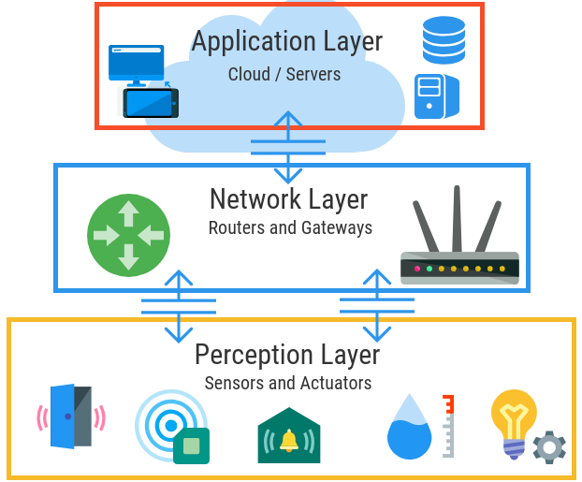
Figure 1: three-layer IoT architecture (Olivia Haring, 2021)
Key Characteristics:
- Simple and widely adopted.
- Suitable for small-scale IoT systems.
- Limited scalability for complex ecosystems.

b) Four-Layer IoT Architecture
Layer | Description | Key Functions
Perception Layer | Collects raw data via sensors and actuators. | Environment sensing
Network Layer | Transmits data securely. | Protocols: MQTT, CoAP, HTTP
Processing Layer | Analyses, stores, and processes data. | Edge devices, cloud services
Application Layer | Presents services and dashboards to users. | Web apps, mobile apps
Table 2: four-layer IoT architecture (Seyyed Keyvan Mousavi, 2021)

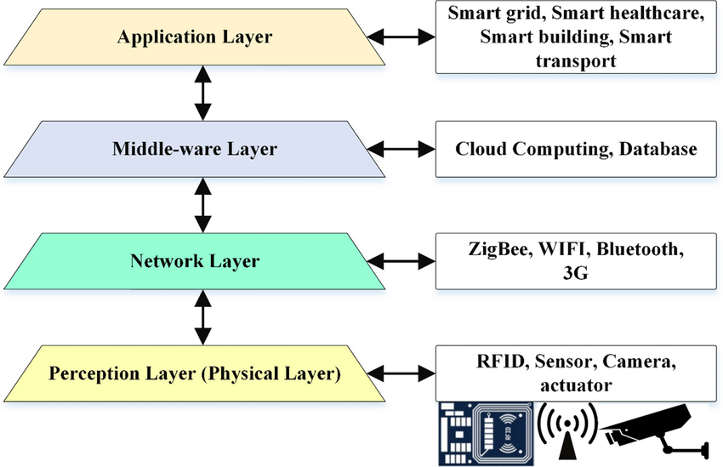
Figure 2: four-layer IoT architecture (Seyyed Keyvan Mousavi, 2021)

Key Characteristics:
- Adds a processing layer to improve data analytics.
- More scalable and efficient than the three-layer model.

c) Five-Layer IoT Architecture
Layer | Description | Key Components
Perception Layer | Sensing and collecting environmental data. | RFID, cameras, sensors
Network Layer | Transmits data between devices and systems. | 5G, Zigbee, LoRaWAN
Edge/Processing Layer | Performs computation close to data source. | Gateways, SBCs, microcontrollers
Application Layer | Interacts with end-users through dashboards. | Mobile apps, visualization tools
Business Layer | Defines goals, policies, and decision-making. | ERP, analytics dashboards
Table 3: five-layer IoT architecture (Liliana Antao, 2018)

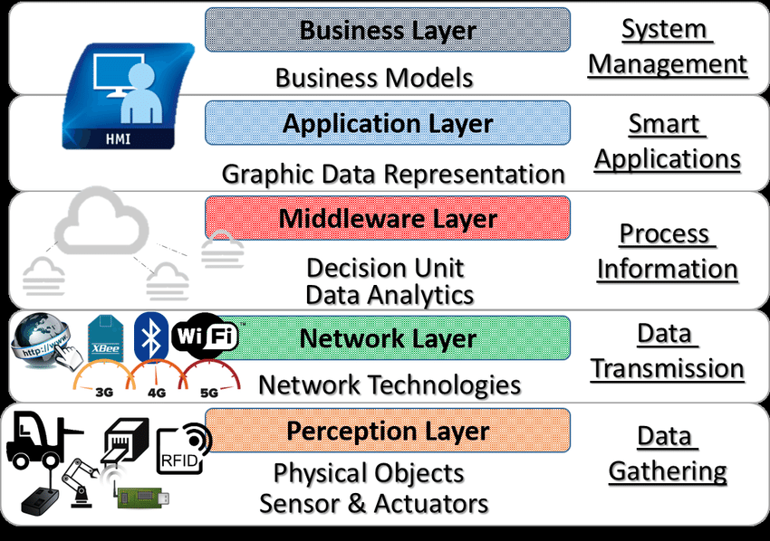
Figure 3: five-layer IoT architecture (Liliana Antao, 2018)

Key Characteristics:
- Most advanced and widely used in modern IoT solutions.
- Enables real-time decision-making and business integration.
- Best suited for large-scale IoT ecosystems.

1.1.3 IoT Frameworks
IoT frameworks provide the essential infrastructure, libraries, and services required to simplify the development, deployment, and management of IoT systems. They offer ready-to-use tools for device communication, data analytics, security, and integration with cloud services. Some widely used IoT frameworks include:

a) AWS IoT Core
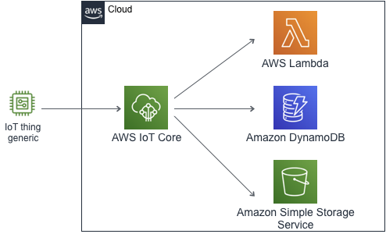
Figure 4: AWS IoT core (佐藤智樹, 2025)

AWS IoT Core, offered by Amazon, is a managed cloud platform that enables secure device connectivity and management at scale.
- Key Features:
  - Secure, bidirectional communication between IoT devices and the cloud.
  - Built-in authentication and encryption mechanisms.
  - Integration with AWS services like Lambda, DynamoDB, and S3 for data storage and processing.
  - Provides Device Shadowing, which allows devices to stay synchronized even when offline.
- Use Case: Ideal for large-scale IoT applications such as industrial automation, predictive maintenance, and energy monitoring (Adamson, 2023).

b) Google Cloud IoT
Google Cloud IoT is a fully managed platform designed for connecting, processing, and analyzing IoT data.
- Key Features:
  - Cloud IoT Core for secure device connections.
  - Integration with BigQuery for large-scale analytics.
  - Advanced AI and Machine Learning tools for predictive analysis.
  - Scalable infrastructure to handle millions of devices simultaneously.
- Use Case: Suitable for applications involving real-time analytics, like smart agriculture, transportation systems, and environmental monitoring (GeeksforGeeks, 2023).

c) Microsoft Azure IoT Hub
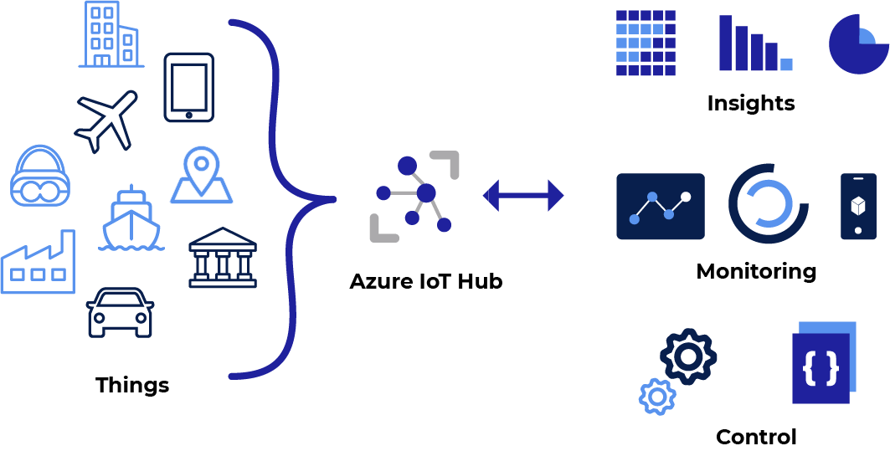
Figure 5: Microsoft Azure IoT (Benmekki, 2022)

Azure IoT Hub is Microsoft’s cloud-based service focused on device-to-cloud and cloud-to-device communication.
- Key Features:
  - Secure communication using protocols like MQTT, AMQP, and HTTPS.
  - IoT Edge capability for running AI models and processing at device level.
  - Integration with Microsoft Power BI for data visualization and reporting.
  - Provides device provisioning, monitoring, and lifecycle management.
- Use Case: Commonly used for enterprise IoT solutions, including supply chain management, fleet tracking, and smart manufacturing (Benmekki, 2022).

d) Kaa IoT Platform
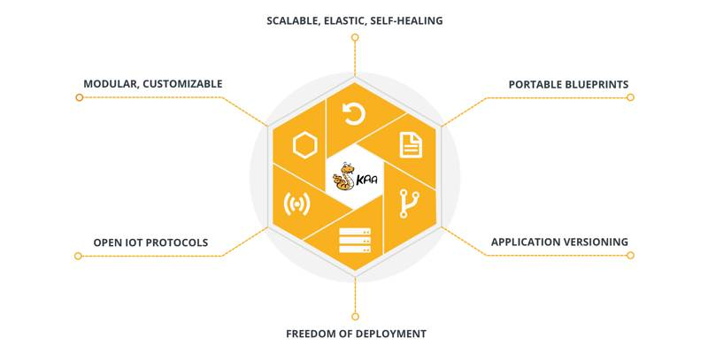
Figure 6: Kaa IoT platform (Wouk, 2019)

Kaa is an open-source, enterprise-grade IoT application development framework.
- Key Features:
  - Offers complete flexibility for customizing device connectivity and data processing.
  - Supports real-time telemetry collection and device management.
  - Easily integrates with cloud platforms like AWS and Google Cloud.
  - Cost-effective since it does not require licensing fees.
- Use Case: Widely used by startups and small to medium businesses for affordable IoT deployments (Wouk, 2019).

e) Node-RED
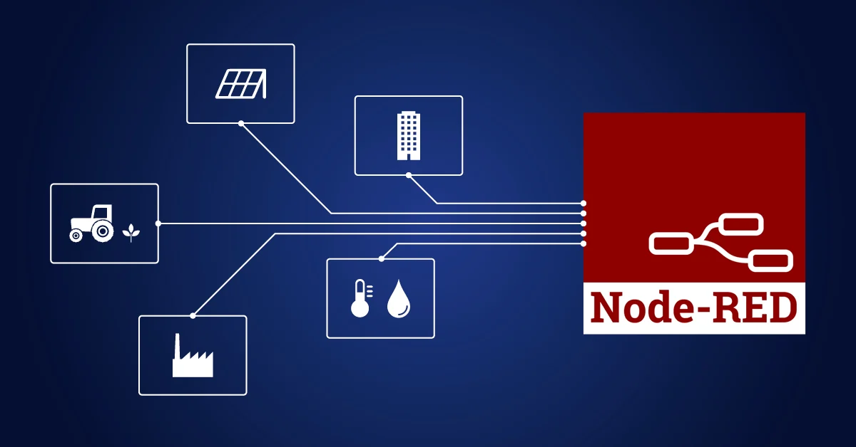
Figure 7: Node-RED IoT platform (Gebhardt, 2020)

Node-RED is an open-source flow-based programming tool specifically designed for IoT prototyping and automation.
- Key Features:
  - Uses a drag-and-drop interface to create automation workflows quickly.
  - Supports MQTT, HTTP, WebSocket, and other IoT communication protocols.
  - Integrates seamlessly with APIs, databases, and external services.
  - Lightweight and suitable for running on low-cost hardware like Raspberry Pi.
- Use Case: Ideal for small-scale IoT prototypes and rapid automation workflows (Gebhardt, 2020).

1.1.4 IoT Development Tools
IoT development tools are used to program devices, manage firmware, simulate environments, and visualize collected data. These tools speed up the development process and improve system performance.

a) Arduino IDE

Figure 8: Arduino IDE (arduino, 2022)

The Arduino IDE is one of the most popular development environments for IoT.
- Purpose: Used to write, compile, and upload code to microcontrollers like Arduino boards and ESP32 modules.
- Features:
  - Supports C and C++ programming.
  - Extensive library supports for sensors, actuators, and communication modules.
  - Highly beginner-friendly and ideal for rapid prototyping.
- Application: Frequently used for sensor integration, basic device control, and automation prototypes (arduino, 2022).

b) PlatformIO

Figure 9: PlatformIO (platformio, 2025)

PlatformIO is a modern, open-source IoT development ecosystem.
- Purpose: Designed for firmware development, debugging, and testing across multiple boards and frameworks.
- Features:
  - Multi-platform and multi-board compatibility (supports Arduino, ESP32, STM32, and more).
  - Cloud-based debugging and integration with CI/CD pipelines.
  - Rich library management for third-party IoT components.
- Application: Used in complex IoT projects requiring advanced debugging and automation testing (platformio, 2025).

c) Eclipse IoT

Figure 10: eclipse IoT (eclipse, 2021)

Eclipse IoT is a collection of open-source IoT projects under the Eclipse Foundation.
- Purpose: Provides tools and libraries for developing connected IoT devices and systems.
- Features:
  - Supports MQTT, CoAP, LwM2M, and REST-based communication.
  - Offers frameworks for device integration and secure connectivity.
  - Provides APIs and SDKs for different programming environments.
- Application: Often used in enterprise-grade IoT solutions requiring cross-platform scalability (eclipse, 2021).
d) ThingSpeak

Figure 11: ThingSpeak (Mishra, 2019)

ThingSpeak is an IoT analytics platform that specializes in data collection and visualization.
- Purpose: Designed for storing and visualizing real-time sensor data.
- Features:
  - Integrates with MATLAB for advanced analytics.
  - REST APIs for seamless integration with IoT devices.
  - Supports triggering alerts and automated responses.
- Application: Widely used for IoT dashboards and real-time monitoring systems (Mishra, 2019).

e) M2MLabs Mainspring

Figure 12: M2MLabs (M2mlabs, 2015)
M2MLabs Mainspring is an open-source IoT framework designed for prototyping connected devices.
- Purpose: Focuses on device management and telemetry storage.
- Features:
  - Supports time-series data storage for historical analysis.
  - Enables rule-based event processing.
  - Designed for machine-to-machine communication systems.
- Application: Used for industrial IoT prototyping and predictive maintenance systems (M2mlabs, 2015).

1.1.5 IoT Hardware
IoT hardware consists of devices and components that sense, process, and transmit data. These components form the foundation of any IoT ecosystem.
a) Microcontrollers
- Low-cost, low-power boards designed to control sensors and actuators.
- Examples: Arduino UNO, ESP32, STM32.
- Use Case: Commonly used for basic IoT tasks like sensor reading, device control, and communication (1nce, 2021).
b) Single-Board Computers (SBCs)
- Compact computers capable of running full operating systems and performing edge-level data processing.
- Examples: Raspberry Pi, NVIDIA Jetson Nano.
- Use Case: Used for AI-based IoT applications, real-time data analytics, and advanced automation (1nce, 2021).
c) Sensors
- Components that detect and collect real-time data from the environment.
- Types include temperature, humidity, motion, CO₂, pressure, vibration, and proximity sensors.
- Use Case: Essential for data-driven IoT solutions like environmental monitoring and occupancy detection.
d) Actuators
- Devices that convert electronic commands into physical actions.
- Examples: Motors, relays, solenoids, servos.
- Use Case: Used to control HVAC systems, lighting, doors, and other automated mechanisms.
e) IoT Gateways
- Gateways serve as bridges between IoT devices and cloud platforms.
- Examples: LoRaWAN Gateways, AWS IoT Greengrass Gateways.
- Use Case: Aggregate data from multiple IoT devices before sending it to cloud platforms for processing (1nce, 2021).

1.1.6 Available IoT APIs
APIs (Application Programming Interfaces) are essential for integrating IoT devices with platforms, dashboards, and third-party applications. They allow seamless communication and enhance interoperability.

a) Blynk API
- A popular IoT platform that enables mobile and web dashboards for device control and monitoring.
- Features:
  - Real-time device communication and control.
  - Data storage and visualization.
  - Push notifications for alerts.
- Use Case: Frequently used in home automation, security monitoring, and remote device control (Blynk, 2022).

b) ThingSpeak API
- An API-driven analytics platform for IoT applications.
- Features:
  - Enables real-time sensor data collection and visualization.
  - Integrates with MATLAB for advanced statistical and predictive analysis.
  - Simple REST API for data upload and retrieval.
- Use Case: Commonly used for building IoT dashboards and research-oriented IoT systems (Readthedocs, 2016).

c) IFTTT API
- IF This Then That (IFTTT) is an automation service that integrates IoT devices with cloud services.
- Features:
  - Trigger-based workflows between devices and applications.
  - Supports integration with hundreds of third-party services.
  - Lightweight and easy to implement.
- Use Case: Ideal for setting up cross-platform IoT automations, like switching lights on when occupancy is detected (IFTTT, 2025).

d) RESTful APIs
- REST APIs are widely used for communication between IoT devices and cloud applications.
- Features:
  - Lightweight, scalable, and simple to implement.
  - Platform-independent and language-agnostic.
  - Widely supported by frameworks and cloud services.
- Use Case: Perfect for integrating IoT devices with dashboards, mobile apps, and cloud databases (Services, 2025).

e) MQTT APIs
- Message Queuing Telemetry Transport (MQTT) is a lightweight messaging protocol widely used in IoT ecosystems.
- Features:
  - Efficient for low-bandwidth, low-power IoT environments.
  - Ensures reliable data transmission using Quality of Service (QoS) levels.
  - Supports publish/subscribe architecture for real-time communication.
- Use Case: Widely used in industrial IoT, smart home systems, and sensor data collection (Mathworks, 2025).

1.2 Analyse the impact of a common IoT ecosystem on the Software Development Life Cycle (SDLC) and evaluate a specific architecture, justifying its effectiveness
IoT systems combine constrained hardware, unreliable networks, real time constraints, and cloud/edge services. That mixture meaningfully changes how software is specified, built, tested, deployed and maintained. Below I first analyse how a typical IoT ecosystem impacts each SDLC phase, then I evaluate a concrete architecture (Edge-Cloud, event-driven microservices + MQTT + serverless backend) and justify why it is effective for a smart-building application such as TechLab.

1.2.1 Impact of a common IoT ecosystem on the SDLC
1. Requirements & planning
- Expanded requirements scope. In addition to functional and UX requirements, teams must specify hardware constraints (sensor accuracy, battery, sampling rate), network characteristics (loss, latency), security/privacy requirements, regulatory constraints (data retention, PII), and operational SLAs. IoT-specific lifecycle models explicitly add “things requirements” and communication requirements to the classic SDLC (Solutions, 2023).

2. System design & architecture
- Multilayer concerns. Designers must plan for device firmware, edge/agent software, network/topology, cloud services, and user apps — and how data flows across them. Architectural concerns such as edge vs cloud processing, message brokers, and event models become primary design decisions (Mauro Chiozzotto, 2025).

3. Implementation (firmware + services + apps)
- Heterogeneous stacks. Implementation spans low-level embedded C/C++ (firmware), constrained RTOS libraries, edge Python/Node.js services, and cloud microservices. This heterogeneity increases integration complexity and requires cross-discipline skillsets (embedded, networking, cloud) (Singleton, 2025).

4. Testing & verification
- Much more complex testing matrix. You must test hardware ↔ firmware ↔ network ↔ edge ↔ cloud ↔ app interactions. This includes device reliability (sensor drift, battery behavior), network partitions, scale tests for message ingestion, and end-to-end latency. Traditional automated unit tests are necessary but insufficient; hardware-in-the-loop, simulation, and field tests become essential (Dziuba, 2021).

5. Deployment & provisioning
- Device lifecycle operations. Secure provisioning, OTA (over-the-air) updates, device identity management, and rollback strategies must be added to deployment processes. Tools that manage certificates, fleet updates, and staged rollouts are critical to avoid bricking devices and to keep the fleet secure (Singleton, 2025).

6. Maintenance & monitoring (post-release)
- Continuous operational concerns. Monitoring requires telemetry from devices (health, connectivity), anomaly detection for predictive maintenance, and fast patching procedures for security vulnerabilities. The operational phase is heavier—fault detection, analytics pipelines, and lifecycle management are ongoing tasks (Mauro Chiozzotto, 2025).

IoT forces the SDLC to become cross-disciplinary (hardware + software + network + ops ), to emphasize integration and field testing, and to treat operations (provisioning/firmware updates/monitoring) as first-class SDLC activities.

1.2.2 Evaluate the Effectiveness of a Specific Architecture: Five-Layer IoT Architecture
The Five-Layer IoT Architecture is composed of the following layers:
1. Perception Layer
Role
- Also called the physical or sensor layer. Responsible for sensing or collecting data from the physical world. Uses sensors, actuators, RFID tags, etc.
- Detects environmental conditions (temperature, motion, moisture, etc.), converts physical phenomena into digital signals (Muhammad Burhan, 2018).
Strengths
- Enables direct interaction with real world; gives the IoT its ability to monitor and respond to physical phenomena.
- If well designed, can provide accurate, high-fidelity data.
- With advances in low‐power sensors, ability to deploy widely and/or in remote places.
Weaknesses
- Power constraints: sensors are often battery powered or energy‐limited; need for low power consumption.
- Reliability and durability: sensors may fail, drift, or be affected by environmental extremes.
- Cost: depending on number, precision, and build quality, can be expensive.
- Security/privacy at the hardware level: sensor tampering, unauthorized access, spoofing.
Example
- Soil moisture sensors and weather stations in precision agriculture measuring moisture, temperature, humidity.
- Wearable devices capturing vital signs (heart rate, blood oxygen) in healthcare monitoring.

2. Network / Transport Layer
Role
- Transmits data collected from perception layer to the processing/middleware layer; handles communication between devices, gateways, cloud, etc.
- Responsible for routing, data transmission, network protocols, sometimes also handling connectivity issues, data integrity (Prabhakaran, 2025).
Strengths
- Enables distributed, remote deployment; allows scaling to many sensors/devices in different locations.
- Variety of technologies/protocols available (Wi-Fi, Bluetooth, LoRaWAN, cellular, etc.), allowing optimization for range, power, latency.
- With good network design, latency, throughput, and reliability can be tuned.
Weaknesses
- Latency and bandwidth limitations, especially for remote or low‐power links.
- Potential for data loss, congestion, interference.
- Security issues: eavesdropping, man‐in‐the‐middle attacks, spoofing.
- Protocol compatibility/interoperability issues (different devices using different standards).
Example
- Using LoRaWAN or NB‐IoT for long‐range, low power sensor data transmission in environmental monitoring.
- Bluetooth / Wi-Fi to send data from wearables to smartphones/gateways.

3. Processing (Middleware) Layer
Role
- Also called middleware; receives raw data from the network layer; handles filtering, aggregation, storage, analysis. May include edge/fog or cloud computing.
- Performs data cleaning, transformation, reduction, sometimes preliminary decision‐making (Choudhary, 2024).
Strengths
- Reduces amount of data that needs to be sent upstream by doing preprocessing (filtering, compression).
- Allows more complex processing, analytics, perhaps machine‐learning, on larger datasets.
- Offers ability to integrate data from heterogeneous sources; handles disparities in format, timing, etc.
Weaknesses
- Resource demands: computing, storage, and possibly energy.
- Latency: processing, especially in cloud, can introduce delays. Edge/fog helps but complicates architecture.
- Complexity: managing middleware infrastructure, deciding where to locate processing (edge vs cloud).
- Security risk: large attack surface; data in transit/at rest needs protection; also risk of faulty or malicious data inputs.
Example
- A smart factory setup: sensor data is aggregated at an edge server which filters anomalies and only relevant data is sent to cloud for deeper analytics.
- Middleware, that performs anomaly detection on streaming environmental data.

4. Application Layer
Role
- Delivers services to end‐users; defines how processed data is used. Interfaces, dashboards, alerts, applications for monitoring, control.
- Helps translate technical data into actionable information relevant to specific use‐cases (Kelly, 2024).
Strengths
- Enables users to interact with IoT system; makes the data meaningful and usable.
- Supports diverse application domains: healthcare, smart homes, industrial automation, etc.
- Can offer customization, visualization, control.
Weaknesses
- Must deal with usability, varying user needs; designing intuitive, secure, responsive applications is non‐trivial.
- Dependence on lower layers: if data is delayed, noisy, or lost, applications suffer.
- Scalability: as number of users/devices grows, maintaining performance and user experience gets harder.
- Security/privacy concerns: access control, privacy of user data, authentication etc.
Example
- Mobile app for farmers showing moisture levels, weather forecasts, and recommending irrigation schedule.
- Dashboard for machine operators showing predictive maintenance alerts.

5. Business Layer
Role
- The top-level layer; concerns business models, management, strategy, policy. It converts data insights into business decisions, ROI analysis, regulatory compliance, privacy, and governance.
- Deals with rules/policies about how the IoT fits into the organization’s objectives (Prabhakaran, 2025).
Strengths
- Ensures alignment of IoT deployment with organizational goals; helps justify investment.
- Incorporates governance, risk management, privacy, legal compliance which are essential for large scale or critical systems.
- Helps in long‐term planning: scaling up, maintenance, service design, monetization.
Weaknesses
- Often abstract; difficult to measure or optimize directly. Business outcomes may lag technical deployment.
- Many external constraints: regulations, market, privacy laws etc., which may slow down or restrict innovation.
- Requires cross‐disciplinary coordination (technical, legal, financial, operational), which is challenging.
- Risk: if business logic is flawed or misaligned, IoT system may not deliver value; wasted resources.
Example
- A company using IoT in supply chain decides how to sell predictive maintenance as a service; integrates IoT metrics into their ERP and financial planning.
- Privacy policy and compliance with health data protection laws when deploying IoT devices for patient monitoring.

1.2.3 Justifying the Effectiveness of the Five-Layer IoT Architecture for Developing IoT Applications
Here are several effectivenesses of using the Five-Layer IoT Architecture when developing IoT applications

- Modularity and Separation of Concerns
The five-layer architecture divides the IoT system into distinct functional layers (Perception, Network/Transport, Processing, Application, Business), each with clear responsibilities. This separation helps manage complexity (Muhammad Burhan, 2018).
Justification:
- Because each layer handles a well-defined set of tasks (e.g. data capturing, transmission, analysis, interface, business logic), developers/designers can focus on one layer without having to deal with the entire system at once.
- Changes or upgrades (such as changing the network protocol, or upgrading data processing infrastructure) can often be done in one layer without massive redesigns in others.
- This makes maintenance, testing, and debugging easier: isolating problems within a specific layer (e.g. if data isn’t arriving, investigate Network layer; if analytics are wrong, check Processing layer).

- Scalability
The architecture supports growth more devices, more data, more users by enabling scaling in each layer independently (Prabhakaran, 2025).
Justification:
- You can increase the number of sensors/devices in the Perception layer without necessarily changing the business logic or application design.
- Transport/Network layer can be scaled (e.g. adding more gateways, using different communication technologies) to handle higher data traffic.
- Processing layer (middleware, cloud or edge) can scale horizontally (more servers, distributed processing) to meet demands of storing and processing increased volume of data.
- The business layer can adapt to more users, more business use-cases, more analytics, without needing to redesign how the perception or transmission of data works.

- Interoperability and Flexibility
The architecture allows for integrating heterogeneous devices, different protocols, varied platforms; and supports future extension or changes (Choudhary, 2024).
Justification:
- Because the layers abstract certain functions (e.g. perception only produces data, network transports, processing transforms/aggregates), it becomes easier to plug in different kinds of sensors or communication methods. E.g. switching a sensor type (temperature, humidity) or integrating a new wireless protocol.
- The processing/middleware layer can accommodate data from diverse sources, normalize or transform it, so the application/business layers can work on consistent, usable data.
- Flexibility helps when business requirements change (e.g. new analytics, new service offerings) – application and business layers can evolve without reworking sensor or network layers heavily.

- Enhanced Security and Privacy Controls Across Layers
Security and privacy risks in IoT are multi-faceted (device tampering, data in transit, storage, misuse). A layered architecture enables security to be addressed at multiple levels (FasterCapital, 2024).
Justification:
- In the Perception layer, you can enforce physical security, device authentication, tamper detection; in the Network layer, you can have secure communication protocols (encryption, secure channels).
- The Processing layer can enforce data integrity, secure storage, access control; Application layer can enforce user‐level authorizations; Business layer can set policies, ensure compliance, auditing.
- Because layers are distinct, you can insert security measures where needed: e.g. encrypt at transport, anonymize or filter personally identifiable information at processing, enforce privacy policies at business layer. This gives a more robust defense-in-depth strategy. This is supported in literature saying that the five-layer model helps address security and storage issues more fully than simpler models.

- Efficient Data Management and Real-Time Processing
IoT systems often generate large volumes of data continuously. The architecture supports mechanisms to process, filter, aggregate data (at edge or middleware) to avoid overwhelming systems or introducing delays (Rupinder, 2025).
Justification:
- The Processing layer (middleware) can filter out redundant or irrelevant data, reducing bandwidth and storage usage. This allows only useful data to be stored/analyzed. For example, aggregation, threshold‐based filtering etc.
- Real-time or near real-time applications benefit when processing is done closer to sources (or via efficient middleware) rather than sending all raw data to cloud. Reducing latency.
- Helps with resource constraint (bandwidth, storage, computational power) by ensuring lower layers reduce load before passing data up.

- Business Value Alignment and Decision-Making Support
The Business layer enables translating technical outputs (data, analytics) into strategic decisions, policy, business models, ROI, regulatory compliance (Rupinder, 2025).
Justification:
- Without a Business layer, an IoT system might produce lots of data but fail to link to actual business outcomes (cost savings, new services, revenue). The architecture forces consideration of how IoT contributes to business goals.
- Helps in planning, governance, strategy: resource allocation, risk management, privacy/policy compliance.
- For example, in deployments in healthcare, smart cities, or industrial IoT, business layer can define metrics (KPIs) for safety, efficiency, cost, etc., which helps decide whether new sensors or algorithms are worth investment.

1.3 Examine a specific form of IOT ecosystem used to solve real-world problem.

1.3.1 Examining a Specific Form of IoT Ecosystem: Smart Healthcare
The Smart Healthcare IoT Ecosystem is one of the most impactful IoT ecosystems, designed to address challenges in the healthcare sector. It integrates IoT technologies, data analytics, and cloud platforms to improve patient care, optimize hospital operations, and enhance overall efficiency in healthcare delivery (Jaimon Terence Kelly, 2020).

Overview of the Smart Healthcare IoT Ecosystem
A Smart Healthcare IoT Ecosystem comprises interconnected medical devices, wearables, hospital management systems, and cloud platforms. These components work together to collect, transmit, and analyze health-related data in real time. The ecosystem spans several domains including remote patient monitoring, medical asset management, predictive diagnostics, and emergency response.

The Problem: Challenges in Traditional Healthcare Systems
Healthcare systems worldwide face operational and clinical challenges that impact both providers and patients:

- Delayed Diagnosis and Treatment: Traditional systems rely heavily on manual check-ups and offline diagnostics, leading to late detection of diseases.
- Resource Inefficiency: Hospitals often experience equipment shortages, inefficient bed allocation, and delays in treatment coordination.
- High Operational Costs: Manual monitoring, repetitive testing, and emergency mismanagement lead to excessive costs.
- Limited Accessibility: Rural or remote patients struggle to access timely medical attention.
- Patient Safety Risks: Medication errors, lack of real-time monitoring, and delayed responses can compromise patient health (biot-med, 2024).

The Smart Healthcare IoT Ecosystem addresses these issues by leveraging real-time monitoring, connected devices, and predictive analytics to transform healthcare delivery.

Components of the Smart Healthcare IoT Ecosystem

1. Sensors and Wearable Devices
Sensors and wearables are critical in gathering continuous health data.
- Heart Rate and ECG Sensors: Monitor cardiovascular activity to detect irregularities.
- Glucose Monitors: Provide real-time blood sugar readings for diabetic patients.
- Temperature and Oxygen Sensors: Track fever and oxygen saturation levels, vital during pandemics.
- Wearables (smartwatches, patches): Provide continuous health monitoring and alert patients and doctors to abnormalities.

2. Connectivity
IoT healthcare devices require reliable communication channels to transmit sensitive data securely.
- Protocols Used: Wi-Fi, Bluetooth Low Energy (BLE), Zigbee, and 5G.
- Purpose: Ensures seamless and secure communication between wearables, hospital systems, and cloud platforms.
- Example: A patient’s smartwatch sends ECG data in real time to a hospital server for continuous monitoring.

3. Cloud Computing and Data Analytics
- Data from sensors is transmitted to cloud platforms where advanced analytics tools identify patterns, predict risks, and recommend interventions.
- Machine learning algorithms can predict health conditions such as heart failure before they occur.
- Electronic Health Records (EHRs) can be integrated into cloud platforms to create a unified patient history accessible by doctors and caregivers.

4. Automation and Control Systems
- Automated alerts and responses reduce manual intervention.
- Examples:
  - Alerts sent to doctors when a patient’s vital signs cross thresholds.
  - Automated medication reminders for patients through smart pill dispensers.
  - AI-based triage systems for emergency prioritization.

5. Mobile Applications and Dashboards
Patients and healthcare providers can access real-time health data through apps and dashboards.
- For Patients: Mobile apps show health metrics, medication reminders, and provide teleconsultation options.
- For Doctors: Dashboards consolidate multiple patients’ data, provide alerts, and support decision-making.
- For Hospitals: Management dashboards track asset utilization, bed occupancy, and resource allocation (Semtech, 2025).

1.3.2 How the Smart Healthcare IoT Ecosystem Solves Real-World Problems

1. Improved Patient Monitoring and Diagnosis
IoT-enabled healthcare systems allow for continuous remote monitoring, reducing the need for frequent hospital visits.
- Example: Cardiac patients wearing ECG-enabled smartwatches can be continuously monitored for irregularities, enabling early intervention (Rawat, 2025).

2. Enhanced Operational Efficiency
Hospitals can improve resource allocation and reduce delays by automating workflows.
- Example: IoT-enabled asset tracking systems ensure medical equipment such as ventilators are efficiently managed and available when needed.

3. Cost Reduction
IoT reduces healthcare costs by preventing emergencies through predictive monitoring, minimizing unnecessary hospital admissions, and enabling telemedicine.
- Example: Remote monitoring of diabetic patients reduces frequent hospital visits, cutting down on treatment costs (J. Malathi, 2024).

4. Better Accessibility and Inclusivity
Rural patients can access healthcare through IoT-powered telehealth solutions.
- Example: A wearable device connected to a telemedicine platform allows doctors in urban hospitals to monitor patients in remote areas.

5. Patient Safety and Personalization
IoT ecosystems improve medication safety and create personalized treatment plans.
- Example: Smart pill dispensers remind patients to take medication at the correct times, reducing the risk of missed or overdosed medication (Garbeva, 2023).

The Smart Healthcare IoT Ecosystem demonstrates how IoT can transform a real-world problem inefficient and inaccessible healthcare into an efficient, secure, and patient-centered system. By integrating sensors, connectivity, cloud analytics, automation, and mobile access, healthcare providers can enhance quality of care, reduce costs, and improve patient safety.

Part 2

2.1 Investigate IoT Architectures, Frameworks, Tools, Hardware, and APIs Used to Solve Problems with Valid Case Studies

The increasing adoption of the Internet of Things (IoT) in smart buildings has reshaped how facilities are managed. By leveraging connected devices, cloud services, and automation technologies, building managers can optimize energy usage, enhance security, and improve occupant experience. At TechLab, a coworking hub, IoT-driven building automation offers a practical demonstration of how modern workspaces can be transformed into efficient, safe, and sustainable environments. This investigation explores the IoT architecture, frameworks, tools, hardware, and APIs that support TechLab’s smart building automation system.

2.1.1 IoT Architecture in Smart Building Automation
A structured IoT architecture ensures seamless communication and coordination between different components in smart buildings. TechLab’s automation system is built on a five-layer model:
- Perception Layer
  - Role: Collects real-time data from physical devices.
  - Components: Temperature sensors for climate monitoring, motion sensors for occupancy detection, light sensors for natural lighting adjustments.
  - Example: Motion sensors track room usage and trigger automated lighting adjustments.
- Network Layer
  - Role: Transfers sensor data to processing systems.
  - Technologies: Wi-Fi and Zigbee are used for indoor data transmission, while LoRaWAN connects devices across larger areas of the facility.
  - Example: Zigbee modules send occupancy data to a central controller for lighting decisions.

- Processing Layer
  - Role: Analyzes and processes the incoming data.
  - Components: Edge devices for local processing, cloud platforms for long-term data storage and advanced analytics.
  - Example: An edge computing unit instantly processes HVAC data to adjust air circulation in a crowded meeting room.
- Application Layer
  - Role: Provides interfaces for monitoring and control.
  - Features: Mobile apps for remote system control, dashboards for facility management.
  - Example: Managers receive alerts through an app when energy consumption exceeds a preset threshold.
- Business Layer
  - Role: Aligns the IoT system with organizational goals.
  - Features: Predictive maintenance, efficiency reports, and sustainability strategies.
  - Example: AI-driven insights recommend shutting down unused HVAC units during low-occupancy hours (dharmendra, 2025).

2.1.2 IoT Frameworks
IoT frameworks streamline the development and integration of smart building systems by providing standardized services and tools.
- AWS IoT Core: Offers secure device connections, data ingestion, and integration with AWS analytics. Used to manage thermostat and lighting data (amazon, 2022).
- Google Cloud IoT: Provides real-time data processing and predictive analytics. At TechLab, it helps optimize occupancy-based lighting schedules.
- Kaa IoT: An open-source platform enabling device management and telemetry monitoring. Useful for managing energy meters and HVAC systems (IoT, 2025).
- ThingsBoard: Supports rule-based automation and visualization. Deployed for managing alerts from security cameras and access control systems (thingsboard, 2017).

2.1.3 IoT Development Tools
Development tools enable programming, prototyping, and automation within the IoT ecosystem.
- Node-RED: A visual tool for creating automation flows. At TechLab, it configures workflows such as automated lighting schedules.
- Arduino IDE: Used for coding microcontrollers that control HVAC systems and lighting.
- PlatformIO: Provides a professional development environment with debugging and multi-board support, used for managing complex sensor networks.
- TinkerCAD: Assists in simulating IoT circuits before deployment, ensuring sensor and actuator behavior is validated beforehand (Swaroop Deshmukh, 2019).

2.1.4 IoT Hardware
The backbone of the IoT ecosystem lies in the hardware components deployed throughout the building.
- Sensors: Include temperature, humidity, motion, and light sensors for real-time monitoring of building conditions.
- Microcontrollers: Boards such as Arduino and ESP32 manage building operations, acting as central controllers for devices.
- Single-Board Computers: Raspberry Pi units act as edge processors, enabling faster response to local data without cloud dependency.
- Communication Modules: Zigbee and LoRa modules provide secure and efficient connectivity across the facility.
- Actuators: Devices such as relays, motors, and servos adjust HVAC systems, manage automated doors, and regulate lighting intensity (Iulia-Antonia BIRLOG, 2020).

2.1.5 IoT APIs
APIs enable integration between IoT devices, cloud services, and user applications.
- AWS IoT API: Connects building devices to AWS dashboards for secure monitoring and automation.
- Google Cloud IoT API: Provides device management and predictive analytics for energy optimization.
- ThingSpeak API: Collects and visualizes sensor data, enabling real-time monitoring of temperature and occupancy.
- IFTTT API: Facilitates automation between different services, such as adjusting blinds automatically based on sunset timings (S. Altayran, 2023).

2.1.6 Case Study: TechLab Smart Building
TechLab adopted a smart building automation system to optimize resource usage and enhance the tenant experience.
- Architecture: Implemented the five-layer IoT architecture for structured management.
- Frameworks: Utilized AWS IoT Core for device connectivity and management.
- Tools: Applied Node-RED for workflow automation and Raspberry Pi for edge processing.
- Hardware: Integrated motion sensors, ESP32 microcontrollers, and Zigbee modules to monitor occupancy and control systems.
- APIs: Deployed AWS IoT APIs to connect devices with centralized dashboards for real-time monitoring.

Outcome:
- Achieved a 30% reduction in energy usage by optimizing lighting and HVAC schedules.
- Enhanced tenant comfort with personalized climate and lighting control.
- Improved security through IoT-enabled cameras and automated alerts.

The integration of IoT architecture, frameworks, tools, hardware, and APIs at TechLab demonstrates how smart building automation can address issues of energy waste, operational inefficiency, and security risks. By leveraging these technologies, smart buildings can deliver sustainable, efficient, and user-friendly environments, aligning with modern standards of workplace management.

2.2 Discuss a Real-World Problem to Solve Related to the Given Scenario by Reviewing a Series of Resources and Literature Articles. Provide the Technical Characteristics/Features of the Components Required in Your Selected Model/System
As coworking spaces like TechLab grow in size and capacity, ensuring safety from potential hazards such as fire outbreaks and gas leaks becomes a critical challenge. In many traditional buildings, fire and gas detection systems rely on manual checks or conventional smoke alarms, which may not provide early or real-time alerts. This can delay emergency responses, increase risks for occupants, and lead to severe property damage. Addressing this issue requires an intelligent, IoT-enabled system that provides real-time monitoring, automated alerts, and remote management to ensure quick responses during emergencies.

2.2.1 Problem Statement
One of the pressing issues in large coworking spaces is the lack of efficient fire and gas detection systems capable of delivering instant alerts to both occupants and facility managers. Conventional systems often detect hazards late, have limited monitoring capability, and rely solely on alarms that may go unnoticed in certain scenarios. Manual monitoring further adds to the problem, as it is resource-intensive and prone to human error.

To overcome these challenges, an IoT-based Fire and Gas Leak Detection System can be developed. By integrating sensors, microcontrollers, and IoT platforms, the system can continuously monitor environmental conditions, detect hazardous gas levels or flames, and trigger both local alarms and remote notifications in real time.

2.2.2 Proposed Solution
The proposed IoT system integrates MQ-2 gas sensors and IR flame sensors with an ESP32 microcontroller to monitor air quality and fire hazards. When abnormal conditions are detected, the system triggers buzzers and LED indicators for local alerts while simultaneously sending notifications via the Blynk mobile application. This ensures that occupants and facility managers are immediately informed, even if they are not physically present.
By combining real-time sensing, automated alerts, and IoT connectivity, this solution enhances safety and provides a reliable, modern approach to hazard detection in coworking spaces.

2.2.3 Literature Review
- Early Hazard Detection with IoT Sensors: Studies such as Sharma & Jain (2019) highlight the effectiveness of IoT-enabled sensors in detecting hazardous gases and smoke levels at early stages. Unlike traditional systems, IoT sensors provide continuous monitoring and minimize delays in hazard identification (Ankit Sharma, 2019).
- IoT-Based Fire Detection Systems: Research by Hassan et al. (2020) demonstrates that flame sensors integrated with IoT platforms can accurately detect fire incidents and trigger immediate alerts. This significantly reduces emergency response time compared to conventional alarms (Ibtehal Mahfoodh Mohammed Al Hasani, 2022).
- Remote Monitoring through IoT Platforms: A report by Cisco (2021) shows that IoT platforms like Blynk and ThingSpeak enhance building safety by enabling remote monitoring and mobile notifications. This ensures that facility managers can respond to emergencies even when off-site (Patty Medberry, 2020).

These studies collectively validate the feasibility and necessity of integrating IoT in fire and gas detection systems for improved safety and faster emergency response.

Technical Characteristics and Features of the Fire and Gas Detection System
1. NodeMCU ESP32 Microcontroller
- Technical Features:
  - Built-in Wi-Fi and Bluetooth for IoT connectivity.
  - Dual-core processor for handling multiple sensor inputs simultaneously.
  - GPIO pins support various sensors and actuators (e.g., gas sensors, flame sensors, buzzers).
- Benefits: Enables real-time data transmission to the Blynk platform and provides a central hub for sensor integration and automation.
- Application in System: Acts as the brain of the system, processing sensor signals and sending alerts to both local alarms and remote devices.

2. MQ-2 Gas Sensor
- Technical Features:
  - Detects gases such as LPG, methane, smoke, and hydrogen.
  - Sensitive to a wide range of combustible gases.
  - Analog output signal provides varying voltage based on gas concentration.
- Benefits: Provides accurate detection of hazardous gas leaks, ensuring safety in co-working environments where kitchens or fuel-based equipment may be present.
- Sensitivity and Range: Effective for detecting gas concentrations in the range of 200–10000 ppm.
- Application in System: Monitors for gas leaks and sends readings to the ESP32 for analysis and alert generation.

3. IR Flame Sensor
- Technical Features:
  - Detects infrared light emitted from flames within a wavelength range of 760 nm to 1100 nm.
  - High sensitivity and fast response time.
  - Adjustable sensitivity with potentiometer calibration.
- Benefits: Provides rapid detection of fire sources, enhancing early-warning capabilities.
- Application in System: Monitors rooms for fire hazards and triggers immediate alerts when flames are detected.

4. Buzzer and LED Indicators
- Technical Features:
  - Buzzer provides an audible alarm upon hazard detection.
  - LEDs offer visual indicators (e.g., red LED for fire/gas alert, green LED for normal conditions).
- Benefits: Ensures that occupants inside the building are immediately alerted to emergencies, even before mobile notifications are received.
- Application in System: Provides on-site emergency signals to evacuate or respond quickly.

5. Blynk Mobile Application
- Technical Features:
  - Cloud-based IoT platform accessible via smartphones.
  - Provides real-time notifications when thresholds are breached.
  - User interface includes monitoring dashboards, alert logs, and remote reset controls.
- Modes of Operation:
  - Automatic Mode: System autonomously sends alerts when sensors detect hazards.
  - Manual Mode: Users can monitor live readings and reset system states.
- Benefits: Allows facility managers to monitor and respond remotely, ensuring continuous safety management.

Implementation and Expected Benefits
- Early Hazard Detection: The system detects gas leaks or fire at an early stage, reducing risks of major incidents.
- Improved Safety: Occupants are immediately alerted via alarms, lights, and mobile notifications, enabling faster evacuation.
- Remote Monitoring: Facility managers can track system status anytime through the Blynk app.
- Cost-Effectiveness: The system uses affordable sensors and microcontrollers, making it a practical solution for coworking spaces.
- Scalability: The system can be expanded to cover multiple rooms and integrated with other building systems like HVAC or sprinklers.

The IoT-based Fire and Gas Leak Detection System provide a reliable, efficient, and scalable solution to one of the most critical challenges in coworking spaces ensuring occupant safety. By combining ESP32, MQ-2 gas sensors, IR flame sensors, buzzers, LEDs, and Blynk, the system offers real-time monitoring, local alerts, and remote notifications, significantly improving hazard response and minimizing risks.

2.3 Plan the Appropriate IoT Architecture and Submit a Development Plan by Applying Selected Techniques and Tools for the Proposed IoT Ecosystem

This report outlines the development plan for an IoT-enabled Fire and Gas Detection System, designed to address the challenges of delayed hazard detection and manual safety management in coworking spaces like TechLab. The proposed system operates automatically through gas and flame detection, ensuring early warnings in case of emergencies. In addition, it provides remote notifications via a mobile application, allowing facility managers and users to respond quickly even when they are not on-site. The primary objectives are to enhance safety, improve emergency response time, and offer reliable remote monitoring.

The report provides an overview of IoT architecture and the development approach for implementing this safety-focused system.

2.3.1 Objectives of the Fire and Gas Detection System
- Gas Leak Detection Using MQ-2 Sensor
  - Objective: Implement the MQ-2 sensor to continuously monitor air quality and detect the presence of hazardous gases such as LPG, methane, and smoke. This feature ensures that potential gas leaks are identified early, reducing risks of explosions or poisoning.

- Flame Detection Using IR Flame Sensor
  - Objective: Use an IR flame sensor to detect fire hazards in real time. The sensor responds quickly to infrared radiation emitted by flames, enabling immediate alerts and faster emergency action.

- Local and Remote Alert System
  - Objective: Activate a buzzer and LEDs as local alarms for on-site occupants and send instant notifications to the user’s smartphone through the Blynk mobile application, ensuring that managers are informed even when they are away.

- Dual Alert Mechanism: Manual and Automatic
  - Objective: Provide automatic detection through sensors while allowing users to monitor and control alerts manually via the mobile application. This ensures flexibility, convenience, and reliability in emergency management.

2.3.2 IoT Architecture for the Fire and Gas Detection System
The proposed system follows the five-layer IoT architecture, where each layer plays a key role in ensuring safety and efficiency.

- Perception Layer
  - Responsible for sensing environmental conditions.
  - Components:
    - MQ-2 Gas Sensor: Detects harmful gases and smoke.
    - IR Flame Sensor: Detects fire hazards by sensing infrared radiation.
    - Buzzer and LEDs: Actuators for providing audible and visual alerts.

- Transport Layer
  - Handles communication between the sensors and the central system.
  - ESP32 microcontroller acts as the bridge, transmitting sensor data over Wi-Fi to the Blynk cloud platform.

- Processing Layer
  - Data from the sensors is processed to determine whether a hazardous condition exists.
  - ESP32 executes the decision-making logic (e.g., trigger buzzer and LEDs if gas concentration or flame is detected).
  - Alerts and data are forwarded to the cloud for storage and remote monitoring.

- Application Layer
  - Provides the interface for users to monitor and interact with the system.
  - Blynk Mobile App enables users to receive notifications, view hazard status, and reset alarms remotely.

- Business Layer
  - Ensures the system aligns with safety goals and organizational policies.
  - Goals include: minimizing fire/gas risks, enhancing safety protocols, and reducing the likelihood of property damage or loss of life.

2.3.3 Development Plan for the IoT Fire and Gas Detection System
1. Tools and Techniques
- Microcontroller: ESP32, chosen for its built-in Wi-Fi, efficient processing power, and compatibility with IoT platforms.
- Gas Sensor (MQ-2): Detects combustible gases and smoke levels in the environment.
- Flame Sensor (IR): Identifies fire hazards quickly and accurately.
- Buzzer: Provides audible alerts in case of emergencies.
- LEDs: Serve as visual indicators for system status (e.g., off = safe, on = hazard detected).
- Mobile Application: Blynk App provides a real-time dashboard, sending push notifications and allowing remote control.
- Development Platform: Arduino IDE for coding and integrating sensor logic with ESP32 and the Blynk platform.

2. Steps in Development
Step 1: Hardware Setup
- Assemble all components: ESP32, MQ-2 sensor, IR flame sensor, buzzer, and LEDs.
- Connect MQ-2 and IR flame sensor to the ESP32’s analog/digital input pins.
- Connect LEDs and buzzer to designated output pins.
- Power the circuit with a regulated 5V power supply.

Step 2: Software Development
- Program the ESP32 using Arduino IDE. Key tasks:
  - Gas Detection Logic: Read analog values from the MQ-2 sensor and trigger alerts when concentrations exceed safe limits.
  - Flame Detection Logic: Process signals from the IR flame sensor to detect fire hazards.
  - Alert System: Control buzzer and LEDs for local warnings.
  - Remote Notifications: Integrate Blynk libraries to push hazard alerts to the mobile app.

Step 3: Mobile Application Development
- Design a dashboard in Blynk App with widgets for:
  - Real-time gas concentration and flame status.
  - ON/OFF control for buzzer reset.
  - Push notification setup for hazard alerts.

Step 4: Testing and Debugging
- Validate sensor performance by simulating gas leaks and flame presence.
- Test Wi-Fi connectivity and ensure Blynk notifications are triggered promptly.
- Debug and optimize code for reliability and responsiveness.

2.3.4 Circuit Diagram Design
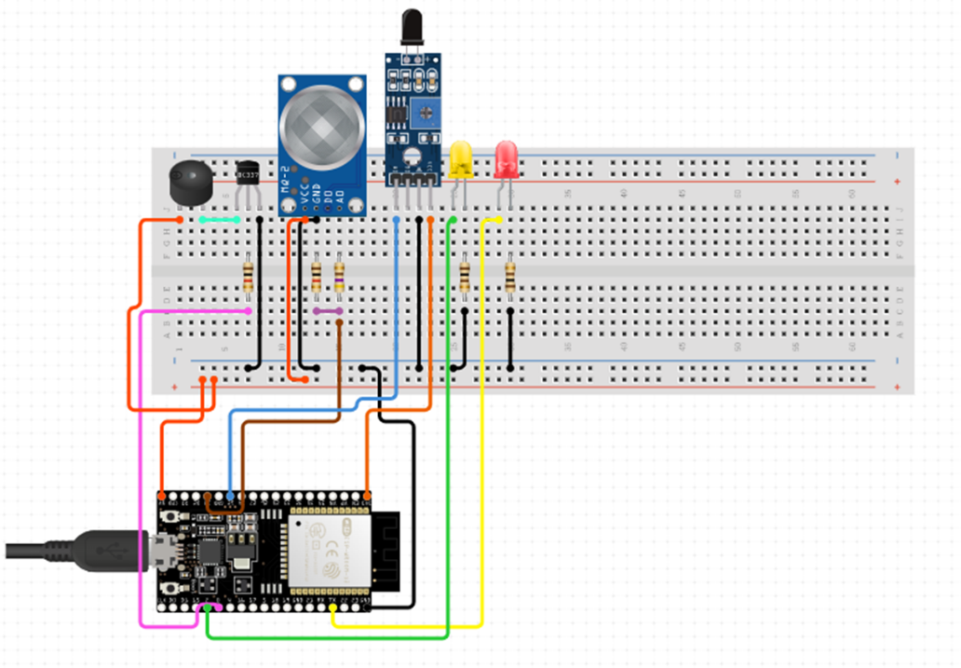
Figure 13: circuit diagram

The circuit diagram highlights the following key components:
- MQ-2 Gas Sensor: Connected to ESP32 analog pin to measure gas concentration.
- IR Flame Sensor: Connected to ESP32 digital input pin for fire detection.
- Buzzer and LEDs: Connected to digital output pins for alert signaling.
- ESP32: Central controller linking sensors and actuators to the Blynk platform via Wi-Fi.

2.3.5 Expected Outcomes
The IoT-enabled Fire and Gas Detection System is expected to provide the following benefits:
- Early Hazard Detection: Quick identification of gas leaks and flames reduces the risk of severe emergencies.
- Real-Time Alerts: Immediate local alarms combined with mobile notifications ensure rapid responses.
- Improved Safety: Occupants are warned instantly, minimizing risks to health and property.
- Remote Monitoring: Facility managers can oversee the system status via Blynk, even when away.
- Scalability: The system can be expanded to cover multiple rooms or integrated with larger safety solutions (e.g., sprinklers, HVAC shutdown).

The development of the IoT-based Fire and Gas Detection System addresses critical safety challenges in coworking spaces like TechLab. By leveraging a five-layer IoT architecture and components such as ESP32, MQ-2, IR flame sensor, buzzer, LEDs, and Blynk, the system ensures efficient, real-time detection and notification of fire or gas hazards. This solution not only enhances occupant safety but also provides scalability for future integration into broader smart building ecosystems.

Part 3

3.1 Develop your IoT Application prototype by employing the design and tools that you have identified. Ensure that code snippets for your development and explained well, use the comment in all your code, and document the use of your IoT API well.

To address the risks of fire hazards and gas leaks in coworking spaces like TechLab, an IoT-enabled Fire and Gas Detection System prototype has been developed. This system integrates sensors, microcontroller, actuators, and cloud-based monitoring to ensure early detection of dangerous conditions. By combining local alarms (buzzer and LEDs) with remote notifications (Blynk mobile app), the system enhances occupant safety and ensures timely emergency response.

3.1.1 System Overview
The Fire and Gas Detection System provides users with two operational alert mechanisms:
- Automatic Detection Mode: Sensors continuously monitor the environment and trigger alarms when fire or hazardous gases are detected.
- Remote Monitoring Mode: Users receive real-time notifications and status updates on their smartphones via the Blynk application, allowing them to take timely action even when off-site.
The ESP32 microcontroller serves as the system’s central controller, managing sensor input, processing alerts, and handling communication with the mobile app.

3.1.2 Hardware Components
The prototype consists of the following components:
- ESP32 Microcontroller: Serves as the central controller, processing sensor data and managing communication with the Blynk platform over Wi-Fi.
- MQ-2 Gas Sensor: Detects smoke, methane, LPG, and other harmful gases in the environment.
- IR Flame Sensor: Identifies fire hazards by detecting infrared light emitted by flames.
- Buzzer: Provides an audible alarm when gas leaks or fire are detected.
- LED Indicators:
  - LED off → Safe condition.
  - LED on → Hazard detected.
- Breadboard and Jumper Wires: Allow easy prototyping and connections between hardware components.
- Power Supply (5V USB): Powers the ESP32 and connected sensors.

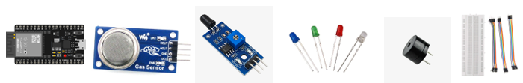
Figure 14: Hardware components used

3.1.3 Software Tools
The development of the prototype made use of the following tools:
- Arduino IDE: Used to write, compile, and upload the program to the ESP32.
- Blynk IoT App: Provides a mobile interface for remote monitoring, push notifications, and control.
- Blynk Library: Enables communication between the ESP32 and the Blynk platform.

3.1.4 Prototype Development for Fire and Gas Detection System
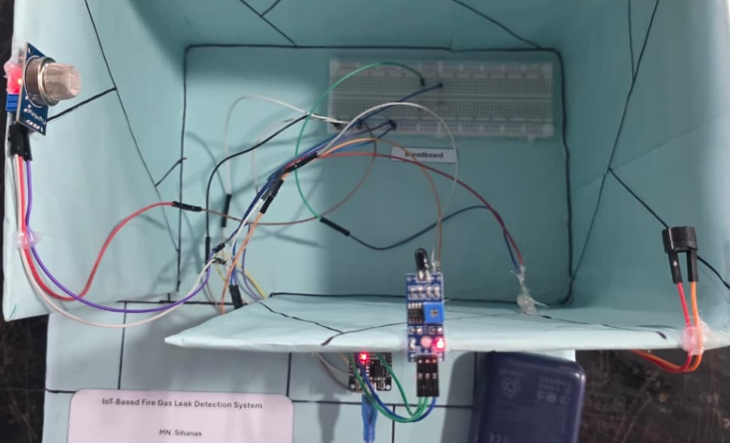
Figure 15: initial prototype

The prototype of the IoT-enabled Fire and Gas Detection System is illustrated above. In this setup:
- The MQ-2 sensor is connected to one of the ESP32’s analog input pins to monitor gas levels.
- The IR flame sensor is connected to a digital input pin for flame detection.
- The buzzer and LEDs are connected to digital output pins to provide immediate local alerts.
- The ESP32 handles both processing and Wi-Fi communication with the Blynk app.

3.1.5 Circuit Diagram Overview
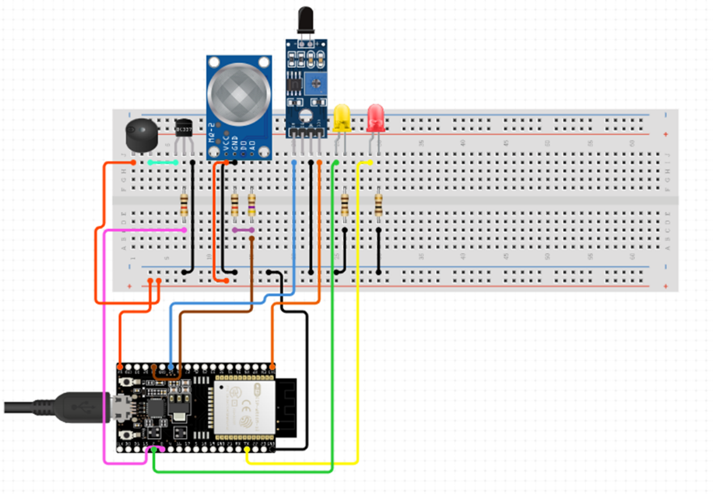
Figure 16: circuit diagram

The circuit connections are as follows:
- MQ-2 Gas Sensor:
  - VCC → 5V
  - GND → Ground
  - Analog OUT → ESP32 analog input pin
- IR Flame Sensor:
  - VCC → 3.3V
  - GND → Ground
  - Digital OUT → ESP32 digital pin
- Buzzer & LEDs:
  - Positive terminals connected to digital output pins.
  - Negative terminals connected to ground.
- ESP32: Acts as the central hub, linking all sensors and actuators to the Blynk platform.

3.1.6 Blynk Mobile Application Configuration
The Blynk app is configured to serve as the user interface for remote monitoring and alert notifications.
Steps in setup:
- Create a New Project: Name it “Fire & Gas Detection System”.
- Design Dashboard:
  - Enable Push Notifications to alert users of detected hazards in real-time.

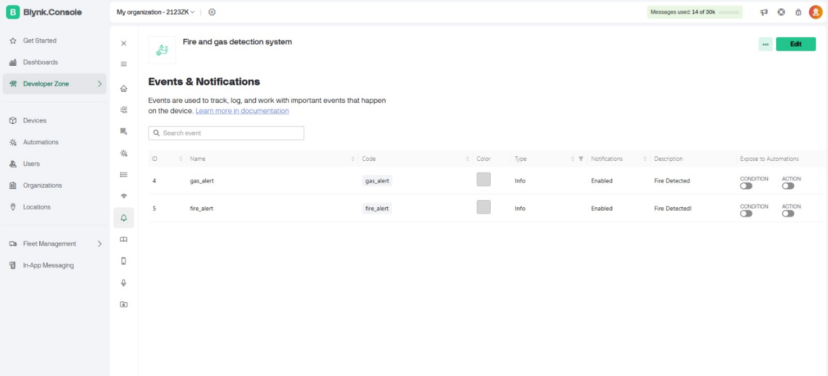
Figure 17: Blynk notification configuration dashboard

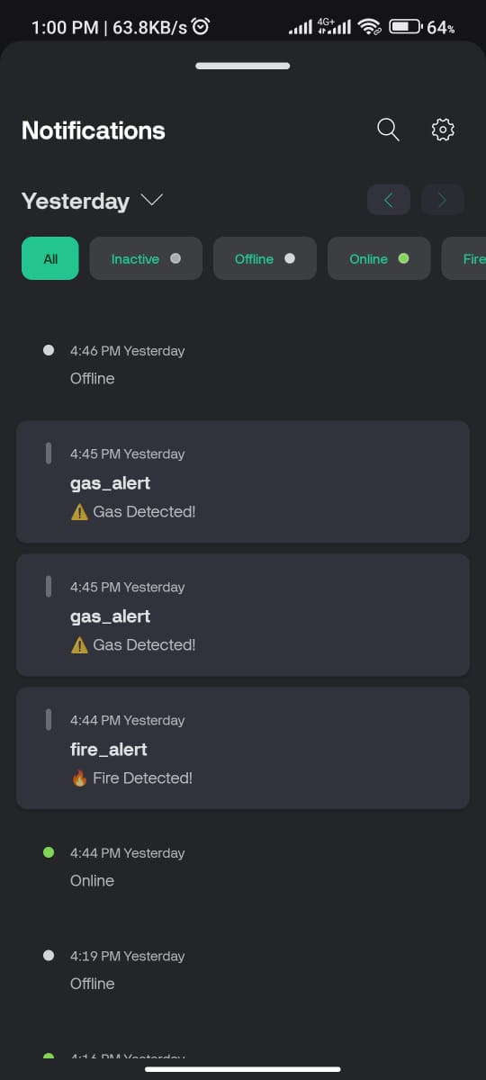
Figure 18: Blynk mobile application alert notification panel

3.1.7 Prototype for an IoT based Fire and Gas detection system
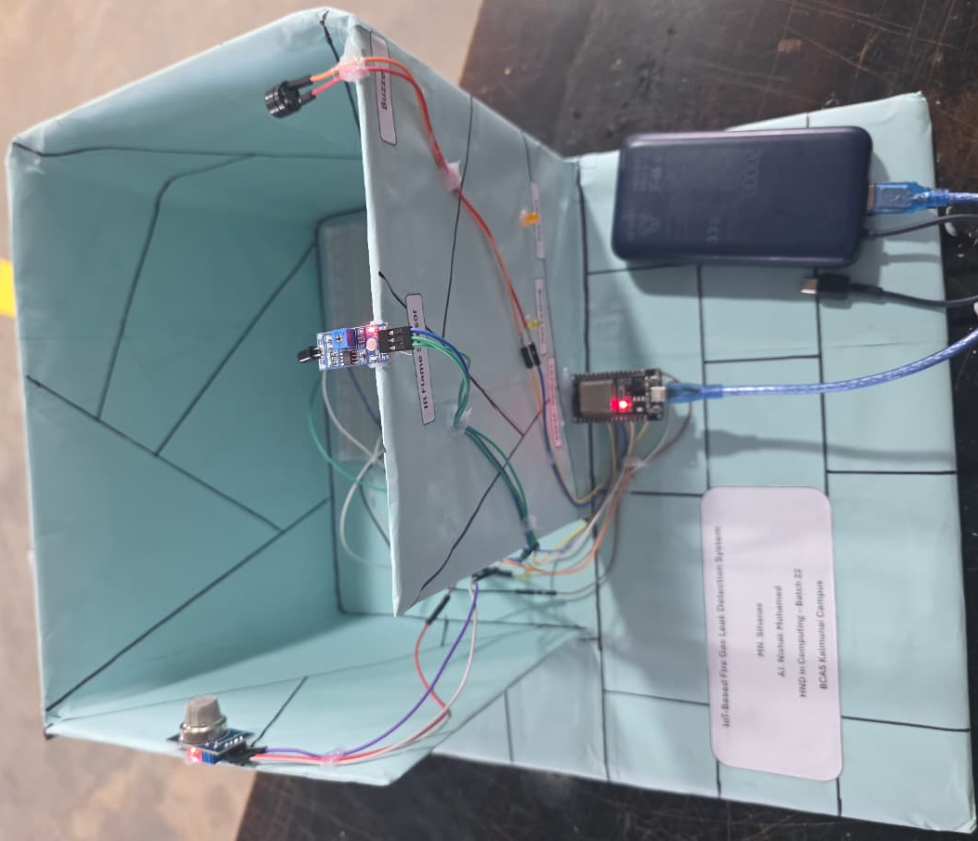
Figure 19: final prototype
In this prototype, the two LEDs act as the lights to be activated if gas leaks or fire detected and are connected to the NodeMCU ESP32. The IR Flame Sensor detects Fire and automatically turns on one of the LED and buzzer, and the MQ-2 sensor detects gas leaks and turns on the other LED and buzzer. Alternatively, the system can be monitored in Remote Mode using the Blynk Mobile Application, allowing users to manage real time alerts and notification on their mobile devices.

3.1.8 Code Implementation
The code is written in Arduino IDE and integrates ESP32, MQ-2, flame sensor, buzzer, LEDs, and Blynk.

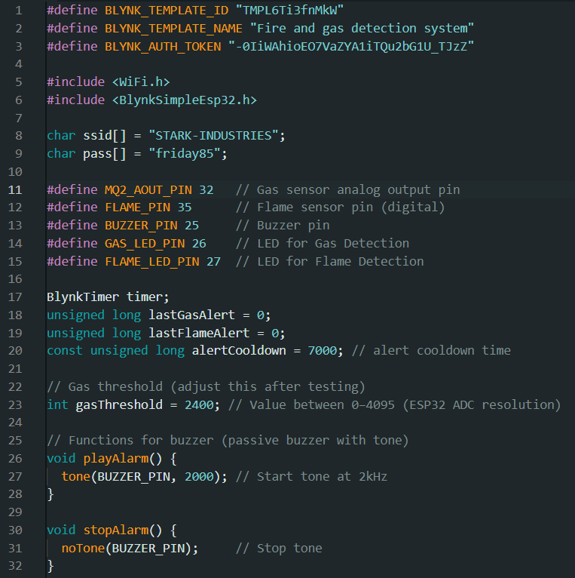
Figure 20: code snippet 1 (with proper comments)
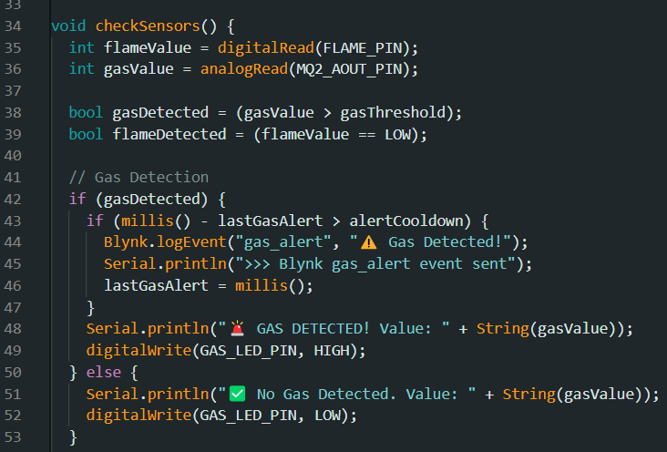
Figure 21: code snippet 2 (with proper comments)

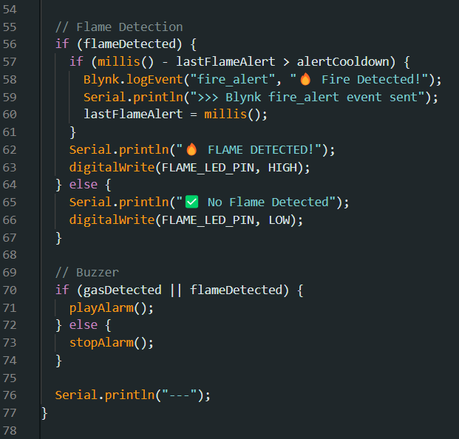
Figure 22: code snippet 3 (with proper comments)

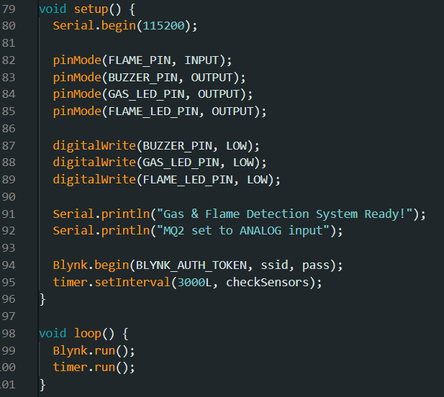
Figure 23: code snippet 4 (with proper comments)

3.1.9 System Testing
Once the code was uploaded to the ESP32, testing was conducted as follows:
- Gas Detection Test:
  - Exposed the MQ-2 sensor to smoke/gas.
  - The system triggered the buzzer, switched on the yellow LED, and sent a push notification to the Blynk app.
- Flame Detection Test:
  - Used a lighter flame at a safe distance near the flame sensor.
  - The buzzer and red LED were activated, and the app notified users immediately.
- Safe Mode Test:
  - In normal air with no flame, the LED stayed off and no alarms were triggered.
- Remote Control Test:
  - On the Blynk app, the notification and alerts are received in real time ensuring remote monitoring functionality.

All tests were successful, confirming that the prototype works as intended and is capable of providing both local alerts and remote notifications in real time.

3.2 Share your solution with end users and gathers feedback and improve the solution based on the given feedback. Iterate this process least 3 times and produce summary for each iteration by evaluating the feedback

Iteration 1: Adjusting the MQ-2 Sensor Threshold
Objective:
In the first version of the system, the MQ-2 gas sensor was highly sensitive, triggering false alarms due to minor smoke or normal variations in air quality. The goal of this iteration was to calibrate the threshold value to ensure alarms are only triggered when actual hazardous gas levels are present.

User Testing:
- Participants: A small group of users was selected to test the initial prototype.
- Testing Period: One week.

User Feedback:
- Frequent false alarms occurred due to overly low sensitivity of the MQ-2 sensor.
- Users reported that unnecessary alarms reduced their trust in the system’s reliability.

Improvements Based on Feedback:
- The gas threshold value in the ESP32 program was increased from a low sensitivity setting (2000) to a more stable threshold of 2400.
- This adjustment allowed the system to ignore harmless fluctuations while still detecting actual gas leaks or smoke hazards.

Summary of Iteration 1:
This iteration resolved the issue of false alarms, making the system more reliable and trustworthy. By fine-tuning the MQ-2 sensor’s threshold, the system became better suited for real-world conditions, reducing unnecessary interruptions while maintaining safety.

Iteration 2: Adding Dual LED Indicators for Real-Time Status
Objective:
In the initial version, users had to rely on the buzzer or the mobile app to confirm hazard detection. To improve visibility and provide instant feedback, the system was enhanced with two LEDs: a green LED for safe conditions and a red LED for hazard alerts.

User Testing:
- Participants: A larger group of users, including new users who had not previously tested the system.
- Testing Period: one week.

User Feedback:
- Users appreciated the buzzer but requested a visual indicator to quickly recognize system status.
- users highlighted that occupants preferred to see a safe/alert status at a glance without opening the mobile app.

Improvements Based on Feedback:
- A yellow LED was added to show gas leak conditions.
- A red LED was added to show fire detection conditions.
- The LEDs were programmed to respond instantly to sensor readings, ensuring real-time feedback.

Summary of Iteration 2:
This iteration improved system usability by providing clear and continuous real-time visual indicators. Users found the LED signals convenient and reassuring, especially in situations where the buzzer alone might not be sufficient.

Iteration 3: Adjusting Alarm and LED Triggering Delay
Objective:
Initially, when gas or flame was detected, the buzzer and LEDs stayed active for a prolonged period, even after the hazard had cleared. This created unnecessary noise and confusion. The aim of this iteration was to optimize the delay period for deactivating alerts.

User Testing:
- Participants: Same group of users from previous iterations to ensure consistent feedback.
- Testing Period: One week.

User Feedback:
- Users reported that the buzzer was disruptive when it continued too long after the hazard cleared.
- users suggested that a shorter reset time would make the system more practical without compromising safety.

Improvements Based on Feedback:
- The alarm delay was reduced so that the buzzer and LEDs turn off promptly (after 7 seconds) once the hazard condition clears.

Summary of Iteration 3:
This iteration enhanced user comfort by optimizing the alarm and LED delay time. Users felt the system was less disruptive while still ensuring a strong and immediate response during hazardous events.

Through three iterations, the Fire and Gas Detection System was refined significantly. Each cycle of feedback and improvement enhanced the accuracy, usability, and reliability of the system. By calibrating the MQ-2 threshold, introducing dual LED indicators, and optimizing alarm timing, the system now provides a balanced solution that ensures early detection, clear feedback, and practical usability for coworking spaces like TechLab.

Part 4

4.1 Review in detail the issues resolve with the proposed solution and investigate the problems faced during the integration including a comparison between the initial plan with the final application.

The IoT-enabled Fire and Gas Detection System was designed to overcome the limitations of traditional safety systems in coworking spaces like TechLab. By integrating MQ-2 gas sensors, IR flame sensors, local alarms (buzzer and LEDs), and the Blynk mobile app, the system provides real-time monitoring and rapid response to potential hazards. Below, the main issues addressed by the system, challenges faced during integration, and a comparison of the initial plan versus the final application are reviewed in detail.

4.1.1 Issues Addressed by the Solution
- Delayed Fire and Gas Hazard Detection
- The Problem: Traditional fire and gas alarms often rely on basic standalone detectors that may not provide early warnings or send notifications to remote users. This delay increases risks of accidents.

- The Solution: The system uses MQ-2 sensors to detect smoke and combustible gases, and an IR flame sensor to identify fire hazards immediately. This ensures faster detection and quicker response times.

- Lack of Remote Monitoring and Alerts
- The Problem: Conventional alarm systems rely only on sirens or lights within the premises, making them ineffective if no one is present.

- The Solution: By integrating with the Blynk app, the system provides real-time push notifications to facility managers’ smartphones. This ensures that hazards are communicated instantly, even when users are off-site.

- Absence of Real-Time Status Indicators
- The Problem: Many existing alarm systems do not provide continuous status visibility (safe vs. hazard). Users must wait for alarms to sound.

- The Solution: The system includes dual LED indicators (green = safe, red = hazard). This allows occupants to visually monitor system status at a glance, improving confidence and usability.

4.1.2 Problems Faced During Integration
- Gas Sensor Sensitivity Calibration
- The Problem: The MQ-2 sensor initially produced false alarms due to sensitivity to minor smoke (e.g., from food or aerosols).

- The Solution: Threshold values were adjusted and tested under controlled conditions to improve accuracy, reducing false positives while still detecting real hazards.

- Flame Sensor Reliability
- The Problem: The IR flame sensor occasionally failed to detect small or distant flames during initial testing.

- The Solution: Sensor positioning was optimized, and sensitivity was fine-tuned to balance range and accuracy, ensuring more reliable fire detection.

- Buzzer and LED Delay Timing
- The Problem: In the first prototype, the buzzer and red LED continued to stay on long after the hazard cleared, frustrating users.

- The Solution: A delay timer was adjusted so that alarms deactivate within 10 seconds after the hazard condition is resolved, while still ensuring users are adequately alerted.

- Network Connectivity Issues
- The Problem: Wi-Fi disconnections occasionally disrupted the Blynk app notifications.

- The Solution: Code optimization was performed to reconnect automatically when Wi-Fi drops, ensuring consistent remote monitoring.

4.1.3 Comparison Between the Initial Plan and the Final Application
- Gas Sensor Sensitivity
- Initial Plan: The MQ-2 sensor was to be used with default factory calibration for gas detection.

- Final Application: The sensor was recalibrated to reduce false alarms, and thresholds were fine-tuned for coworking environments. This provided more reliable performance.

- Fire Detection Method
- Initial Plan: A basic flame sensor was included to detect visible fire.

- Final Application: The IR flame sensor was fine-tuned and strategically positioned, providing stronger reliability in detecting small or distant flames.

- Alert Mechanism
- Initial Plan: The plan was to rely mainly on a buzzer as the local alarm system.

- Final Application: Dual LED indicators (red and yellow) were added alongside the buzzer, offering continuous real-time feedback on system status. This improved usability and reassurance for occupants.

- Remote Monitoring
- Initial Plan: The Blynk app was initially planned only for monitor the notifications.

- Final Application: The app was enhanced to display real-time alerts, and hazard status. This gave users a more interactive and powerful monitoring tool.

By resolving critical issues such as delayed hazard detection, lack of remote monitoring, and unclear status feedback, the IoT-enabled Fire and Gas Detection System evolved into a robust, user-friendly, and reliable application. Although challenges like sensor calibration, timing adjustments, and connectivity had to be addressed, the final product exceeded the initial plan by incorporating dual indicators, refined sensitivity settings, and advanced app features. These improvements significantly enhanced system performance, usability, and safety for coworking spaces like TechLab.

4.2 Critically evaluate the overall success and failure of the given solution and explain the potential impact on people, business community and the end user.

The IoT-enabled Fire and Gas Detection System was developed to address critical safety challenges in coworking spaces like TechLab, such as the late detection of hazards, lack of remote alerts, and limited control in traditional alarm systems. By integrating gas and flame sensors with local (buzzer and LEDs) and remote (Blynk app) alert mechanisms, the system enhances safety, reliability, and convenience. This evaluation reviews the system’s overall success, its shortcomings, and its potential impact on individuals, businesses, and end users.

4.2.1 Evaluation of Overall Success
- Early Hazard Detection
- Success: The MQ-2 gas sensor and IR flame sensor successfully detect smoke, LPG, and flames in real-time. Immediate activation of buzzer and LEDs ensures occupants are warned promptly.

- Impact: Early detection minimizes risks of accidents, giving both individuals and businesses more time to respond to emergencies.

- Dual Alert Mechanism
- Success: The system provides both local alerts (buzzer and LEDs) and remote notifications via the Blynk app. Users can be notified on-site or off-site, making the system more reliable than traditional alarms.

- Impact: Users gain peace of mind knowing they will be alerted instantly even when they are away, ensuring timely response.

- Real-Time Status Indicators
- Success: The addition of dual LED indicators (off for safe, on for hazard) offers clear and continuous visibility of system status.

- Impact: Occupants feel reassured and can quickly identify whether conditions are safe, without needing to open the app.

- Remote Monitoring and alerts.
- Success: The Blynk app provides notifications, and alerts. This ensures in emergency response.

- Impact: Users can remotely manage the system, add convenience and reducing panic during false alarms.

4.2.3 Impact on People, Business Community, and End Users
- Impact on People
- Positive Impact: The system enhances occupant safety by ensuring timely detection of hazards and providing immediate alerts. Individuals benefit from peace of mind, knowing that both visible (LEDs) and audible (buzzer) alerts will warn them of danger.

- Convenience: Remote monitoring through the Blynk app allows individuals to stay informed about workplace safety conditions, even if they are off-site.

- Impact on the Business Community
- Positive Impact: Businesses benefit from reduced risks of fire-related damage, liability, and downtime. By preventing or mitigating hazards early, operational continuity is protected.

- Operational Efficiency: The system reduces reliance on manual safety checks, allowing facility managers to monitor conditions remotely. This improves efficiency and lowers maintenance costs compared to traditional systems.

- Reputation and Compliance: Adopting IoT-based safety solutions demonstrates a commitment to employee well-being and regulatory compliance, which enhances reputation and builds trust with clients.

- Impact on End Users
- Positive Impact: End users experience improved safety and assurance in coworking spaces. Real-time alerts and visible indicators (LEDs) create confidence in the system’s reliability.

- User Experience: The mobile app provides an intuitive and accessible interface, enabling users to receive hazard notifications instantly. This enhances user engagement and promotes widespread adoption.

The IoT-enabled Fire and Gas Detection System has been highly successful in addressing key safety concerns such as delayed hazard detection, lack of remote notifications, and limited user control in coworking spaces. Its integration of sensors, actuators, mobile app monitoring, and dual alert mechanisms has created a robust, efficient, and user-friendly solution.
Although minor challenges such as sensor sensitivity calibration and Wi-Fi connectivity were encountered, they were largely resolved through iterative improvements.

The overall impact has been overwhelmingly positive:
- For individuals, it offers enhanced safety, convenience, and peace of mind.
- For businesses, it reduces risks, ensures compliance, and improves operational efficiency.
- For end users, it provides a safer, more reliable, and easy-to-use safety monitoring system.

This project demonstrates the transformative role of IoT in modern safety management, setting a benchmark for future smart building safety applications.

Conclusion

The development of the IoT-enabled Fire and Gas Detection System has demonstrated how smart technologies can significantly enhance safety and efficiency in coworking environments like TechLab. By integrating sensors (MQ-2 and IR flame), actuators (buzzer and LEDs), and IoT platforms such as the ESP32 and Blynk app, the system successfully addressed key challenges of delayed hazard detection, lack of remote monitoring, and limited user control in traditional safety solutions. Through iterative improvements, the prototype evolved into a reliable and user-friendly application that provides real-time alerts, dual alert mechanisms, and remote management capabilities. The solution not only strengthens occupant safety and peace of mind but also benefits businesses by reducing risks, improving operational efficiency, and aligning with modern IoT-driven building management practices. Overall, this project highlights the transformative role of IoT in creating safer, smarter, and more sustainable environments.

References
1nce, 2021. 1nce.com. [Online]
Available at: https://www.1nce.com/en-ap/resources/news/blog/iot-hardware-and-ecosystem
[Accessed 1 9 2025].
Adamson, C., 2023. Medium. [Online]
Available at: https://medium.com/@christopheradamson253/introduction-to-aws-iot-core-connecting-devices-to-the-cloud-c9ec7d900696
[Accessed 30 8 2025].
amazon, 2022. Amazon.com. [Online]
Available at: https://docs.aws.amazon.com/iot/
[Accessed 7 9 2025].
Amazon, 2025. Amazon.com. [Online]
Available at: https://docs.aws.amazon.com/wellarchitected/latest/iot-lens/iot-edge-computing.htm
[Accessed 3 9 2025].
Amazon, 2025. Amazon.com. [Online]
Available at: https://docs.aws.amazon.com/wellarchitected/latest/iot-lens/architecture-selection.html
[Accessed 3 9 2025].
Amazon, 2025. Amazon.com. [Online]
Available at: https://docs.aws.amazon.com/wellarchitected/latest/iot-lens/architecture-selection.html
[Accessed 4 9 2025].
Ankit Sharma, A. S. S. J., 2019. ACCIDENT DETECTION SYSTEM BASED ON INTERNET OF THINGS(IoT). JETIR.
Anon., n.d. [Online]
Available at: https://docs.aws.amazon.com/wellarchitected/latest/iot-lens/architecture-selection.htm
arduino, 2022. docs.arduino.cc. [Online]
Available at: https://docs.arduino.cc/learn/starting-guide/whats-arduino/
[Accessed 1 9 2025].
Authority, D., 2023. Device Authority. [Online]
Available at: https://deviceauthority.com/unpacking-iot-architecture-layers-and-components-explained/
[Accessed 15 8 2025].
Benmekki, A., 2022. Le blog de Cellenza. [Online]
Available at: https://blog.cellenza.com/en/data/what-is-azure-iot-hub/
[Accessed 30 8 2025].
biot-med, 2024. www.biot-med.com. [Online]
Available at: https://www.biot-med.com/resources/iot-in-healthcare-benefits-challenges-and-use-cases
[Accessed 6 9 2025].
Blynk, 2022. Blynk.io. [Online]
Available at: https://docs.blynk.io/en/
[Accessed 1 9 2025].
Briskinfosec, 2022. Briskinfosec.com. [Online]
Available at: https://www.briskinfosec.com/blogs/blogsdetail/Security-and-Privacy-in-IoT
[Accessed 25 8 2025].
Choudhary, A., 2024. Discover Internet of Things. [Online]
Available at: https://link.springer.com/article/10.1007/s43926-024-00084-3
[Accessed 3 9 2025].
Choudhary, A., 2024. Internet of Things: a comprehensive overview, architectures, applications, simulation tools, challenges and future directions. Discover Internet of Things, 4(1).
dharmendra, 2025. SlideShare. [Online]
Available at: https://www.slideshare.net/slideshow/understanding-iot-and-the-5-layer-architecture-of-the-internet-of-things/276920171
[Accessed 6 9 2025].
Digi, 2024. Digi.com. [Online]
Available at: https://www.digi.com/blog/post/iot-applications-for-smart-buildings-use-cases-and
[Accessed 15 8 2025].
Dziuba, A., 2021. Relevant Software. [Online]
Available at: https://relevant.software/blog/iot-testing-importance
[Accessed 3 9 2025].
E Oye, S. D., 2021. research gate. [Online]
Available at: https://www.researchgate.net/publication/391834252_Exploration_of_IoT_Integration_Techniques_for_Enhanced_Connectivity_and_Remote_Management_of_Smart_Cleaning_Robots
[Accessed 25 8 2025].
eclipse, 2021. Readthedocs.io. [Online]
Available at: https://iottestware.readthedocs.io/en/master/
[Accessed 1 9 2025].
Examcollection, 2025. Examcollection.com. [Online]
Available at: https://www.examcollection.com/blog/mastering-aws-iot-core-strategies-for-scalability-security-and-sustainable-innovation
[Accessed 3 9 2025].
FasterCapital, 2024. FasterCapital. [Online]
Available at: https://fastercapital.com/term/advantages-of-iot-network-layers.html
[Accessed 5 9 2025].
Garbeva, A., 2023. BGO Software. [Online]
Available at: https://www.bgosoftware.com/blog/10-internet-of-things-iot-healthcare-examples/
[Accessed 6 9 2025].
Gebhardt, P., 2020. Paessler.com. [Online]
Available at: https://blog.paessler.com/prtg-and-node-red-building-iot-like-never-before
[Accessed 30 8 2025].
GeeksforGeeks, 2021. GeeksforGeeks. [Online]
Available at: https://www.geeksforgeeks.org/computer-networks/3-layer-iot-architecture/
[Accessed 26 8 2025].
GeeksforGeeks, 2023. GeeksforGeeks. [Online]
Available at: https://www.geeksforgeeks.org/devops/google-cloud-iot-core/
[Accessed 30 8 2025].
Halvorsen, H.-P., 2025. www.halvorsen.blog. [Online]
Available at: https://www.halvorsen.blog/documents/technology/iot/thingspeak/thingspeak.php
[Accessed 1 9 2025].
Ibtehal Mahfoodh Mohammed Al Hasani, S. I. A. K. R. A. S. R. H. S. H., 2022. IoT based Fire Alerting Smart System. Sir Syed University Research Journal of Engineering & Technology, 12(2), pp. 46-50.
IFTTT, 2025. IFTTT. [Online]
Available at: https://ifttt.com/docs
[Accessed 2 9 2025].
Imply, 2024. Imply. [Online]
Available at: https://imply.io/blog/aws-iot-core
[Accessed 3 9 2025].
Infiniticube, 2024. Infiniticube. [Online]
Available at: https://infiniticube.com/blog/iot-sensors-types-and-applications/
[Accessed 25 8 2025].
IoT, K., 2025. Kaa IoT platform. [Online]
Available at: https://www.kaaiot.com/
[Accessed 7 9 2025].
Iulia-Antonia BIRLOG, D.-M. B. G.-M. C., 2020. ResearchGate. [Online]
Available at: https://www.researchgate.net/publication/342869071_Internet_of_Things_Hardware_and_Software
[Accessed 7 9 2025].
J. Malathi, K. R. K. S. I. A. R. M. R. S. B., 2024. IoT-Enabled Remote Patient Monitoring for Chronic Disease Management and Cost Savings. Advances in computational intelligence and robotics book series, pp. 371-388.
Jaimon Terence Kelly, K. L. C. E. G. P. S., 2020. The internet of things: Impact and implications for healthcare delivery. Journal of Medical Internet Research, 12(11), p. e20135.
KaaIoT, 2023. KaaIoT. [Online]
Available at: https://www.kaaiot.com/blog/connect-devices-to-the-iot-platform-with-node-red
[Accessed 15 8 2025].
Kelly, I., 2024. Lightpoint Global. [Online]
Available at: https://lightpointglobal.com/blog/iot-architecture-key-components-and-challenges
[Accessed 4 9 2025].
Liliana Antao, R. P. J. R. G. G., 2018. Requirements for Testing and Validating the Industrial Internet of Things. 2018 IEEE International Conference on Software Testing, Verification and Validation Workshops (ICSTW).
M2mlabs, 2015. M2mlabs.com. [Online]
Available at: http://www.m2mlabs.com/documentation
[Accessed 1 9 2025].
Mathworks, 2025. Mathworks.com. [Online]
Available at: https://www.mathworks.com/help/thingspeak/mqtt-api.html
[Accessed 2 9 2025].
Mauro Chiozzotto, M. A. R., 2025. What Is the Best Solution for Smart Buildings? A Case Study of Fog, Edge Computing and Smart IoT Devices. Applied Sciences, 15(7), p. 3805.
Mishra, H., 2019. IoTbyHVM - Bits & Bytes of IoT. [Online]
Available at: https://iotbyhvm.ooo/thingspeak-iot-platform/
[Accessed 1 9 2025].
Moffa, A., 2023. ptc.com. [Online]
Available at: https://www.ptc.com/en/blogs/iiot/what-is-iot-predictive-maintenance
[Accessed 25 8 2025].
Muhammad Burhan, R. R. B. K. B.-S. K., 2018. IoT Elements, Layered Architectures and Security Issues: A Comprehensive Survey. Sensors, 18(9), p. 2796.
Netmaker, 2024. Netmaker.io. [Online]
Available at: https://www.netmaker.io/resources/smart-building-automation
[Accessed 15 8 2025].
Olivia Haring, S. W. A. N. E., 2021. A Review of Network Evolution towards a Smart Connected World. International Journal of Computer Applications, 183(5), pp. 1-8.
Oliynyk, K., 2024. webbylab. [Online]
Available at: https://webbylab.com/blog/actuators-in-iot-guide/
[Accessed 25 8 2025].
Patty Medberry, P. M., 2020. Cisco Blogs. [Online]
Available at: https://blogs.cisco.com/industrial-iot/industrial-iot-top-3-trends-for-2021
[Accessed 8 9 2025].
platformio, 2025. docs.platformio.org. [Online]
Available at: https://docs.platformio.org/en/latest/what-is-platformio.html
[Accessed 1 9 2025].
Prabhakaran, P., 2025. ItsMyBot. [Online]
Available at: https://itsmybot.com/5-layer-architecture-of-internet-of-things
[Accessed 3 9 2025].
Pratt, M. K., 2023. tech target. [Online]
Available at: https://www.techtarget.com/iotagenda/tip/Top-12-most-commonly-used-IoT-protocols-and-standards
[Accessed 15 8 2025].
Ptc, 2023. Ptc.com. [Online]
Available at: https://www.ptc.com/en/blogs/iiot/what-is-iot-remote-monitoring
[Accessed 25 8 2025].
Rawat, A., 2025. Appinventiv. [Online]
Available at: https://appinventiv.com/blog/iot-based-remote-patient-monitoring-system/
[Accessed 6 9 2025].
Readthedocs, 2016. Readthedocs.io. [Online]
Available at: https://thingspeak.readthedocs.io/en/latest/api.html
[Accessed 2 9 2025].
Rupinder, 2025. Intellipaat. [Online]
Available at: https://intellipaat.com/blog/iot-architecture
[Accessed 5 9 2025].
S. Altayran, T. H. W. E., 2023. APIs in internet of things communications security threats and solutions. IET conference proceedings., 2022(26), pp. 458-463.
Semtech, 2025. Semtech.com. [Online]
Available at: https://www.semtech.com/applications/internet-of-things/smart-healthcare
[Accessed 6 9 2025].
Services, A. W., 2024. Amazon Web Services. [Online]
Available at: https://aws.amazon.com/blogs/iot/emerging-architecture-patterns-for-integrating-iot-and-generative-ai-on-aws
[Accessed 3 9 2025].
Services, A. W., 2025. Amazon Web Services, Inc.. [Online]
Available at: https://aws.amazon.com/what-is/restful-api/
[Accessed 2 9 2025].
Seyyed Keyvan Mousavi, A. G. S. B. H. A., 2021. ResearchGate. [Online]
Available at: https://www.researchgate.net/publication/348537924_Security_of_internet_of_things_based_on_cryptographic_algorithms_a_survey
[Accessed 28 8 2025].
Singleton, S., 2025. Memfault. [Online]
Available at: https://memfault.com/blog/decoding-the-iot-product-development-process
[Accessed 3 9 2025].
Solutions, A., 2023. AnelaTek Solutions. [Online]
Available at: https://anela-tek.com/iot-internet-of-things-sdlc-software-development-life-cycle/?utm_source=chatgpt.com
[Accessed 3 9 2025].
Swaroop Deshmukh, C. D., 2019. research gate. [Online]
Available at: https://www.researchgate.net/publication/335233372_STUDY_OF_INTERNET_OF_THINGS_AND_DEVELOPMENT_TOOLS_AND_TECHNOLOGY
[Accessed 7 9 2025].
Systems, Z., 2023. ZPE Systems. [Online]
Available at: https://zpesystems.com/resources/understanding-smart-building-automation-systems-the-ultimate-guide-zs
[Accessed 15 8 2025].
Talks, A. P., 2023. Medium. [Online]
Available at: https://medium.com/@anshulpaltalks/exploring-the-7-layers-of-the-internet-of-things-iot-e138f5e90bc2
[Accessed 15 8 2025].
Technologies, T. O., 2022. IoT For All. [Online]
Available at: https://www.iotforall.com/top-iot-tools-and-platforms-for-iot-development-and-developers
[Accessed 15 8 2025].
thingsboard, 2017. ThingsBoard. [Online]
Available at: https://thingsboard.io/
[Accessed 7 9 2025].
Wouk, K., 2019. IoT Tech Trends. [Online]
Available at: https://www.iottechtrends.com/kaa-open-source-iot-platform/
[Accessed 30 8 2025].
佐藤智樹, 2025. 【入門】AWS IoT Coreを理解するために必要な6つのポイント | DevelopersIO. [Online]
Available at: https://dev.classmethod.jp/articles/aws-iot-core-introduction/
[Accessed 30 8 2025].

